**ASSIGNMENT FINAL REPORT**

|  |  |  |  |
| --- | --- | --- | --- |
| **Qualification** | **BTEC Level 5 HND Diploma in Computing** | | |
| **Unit number and title** | **Unit 4: Database Design & Development** | | |
| **Submission date** |  | **Date Received 1st submission** |  |
| **Re-submission Date** |  | **Date Received 2nd submission** |  |
| **Student Name** | HOANG ANH QUAN | **Student ID** | BD00812 |
| **Class** | SE07203 | **Assessor name** | NGUYEN SI THIN |
| **Plagiarism**  Plagiarism is a particular form of cheating. Plagiarism must be avoided at all costs and students who break the rules, however innocently, may be penalised. It is your responsibility to ensure that you understand correct referencing practices. As a university level student, you are expected to use appropriate references throughout and keep carefully detailed notes of all your sources of materials for material you have used in your work, including any material downloaded from the Internet. Please consult the relevant unit lecturer or your course tutor if you need any further advice.  **Student Declaration**  I certify that the assignment submission is entirely my own work and I fully understand the consequences of plagiarism. I declare that the work submitted for assessment has been carried out without assistance other than that which is acceptable according to the rules of the specification. I  certify I have clearly referenced any sources and any artificial intelligence (AI) tools used in the work. I understand that making a false declaration is a form of malpractice. | | | |
|  |  | **Student’s signature** |  |

**Grading grid**

|  |  |  |  |  |  |  |  |  |  |  |  |  |
| --- | --- | --- | --- | --- | --- | --- | --- | --- | --- | --- | --- | --- |
| P1 | P2 | P3 | P4 | P5 | M1 | M2 | M3 | M4 | M5 | D1 | D2 | D3 |
|  |  |  |  |  |  |  |  |  |  |  |  |  |

|  |  |  |
| --- | --- | --- |
| **r Summative Feedback: r Resubmission Feedback:** | | |
| **Grade:** | **Assessor Signature:** | **Date:** |
| **Internal Verifier’s Comments:** | | |
| **Signature & Date:** | | |

**Table Of Content**

Table Of Content 2

Table Of Figure 5

List Of Tables 13

Introduction 13

CHAPTER 1: Use an appropriate design tool to design a relational database system for a substantial problem ( L01) 15

1.1 Design a relational database system using appropriate design tools and techniques, containing at least four interrelated tables, with clear statements of user and system requirements. (P1) 15

1.1.1 Identify the problem to be solved by the relational database management system: 15

1.1.1.1 User Requirements 17

1.1.1.2 System Requirements 18

1.1.2 Design tables of entities and properties related to the problem: 19

1.1.3 Draw an Entity-Relationship Diagram (ERD) to illustrate the entities and the relationships between them: 23

1.1.3.1 Relationship: 24

1.1.3.2 IDENTIFY THE PRIMARY KEY ( PK ) AND THE FOREIGN KEY ( FK ): 25

1.1.3.3 ERD: 26

1.1.4 Design the tables needed in the database, the columns corresponding to the attributes, and the data type for each column: 28

1.1.5 Set up primary keys and foreign keys to ensure data integrity: 32

1.1.6 Normalize the database to eliminate duplicate data and ensure data consistency: 34

1.1.6.1 Normalization definition: 34

1.1.6.2 Purpose of normalization: 35

1.1.6.3 Types of Database Normalization: 35

1.2 Produce a comprehensive design for a fully-functional system, which includes interface and output designs, data validations and data normalisation (M1) 37

1.2.1 Produce mockups or wireframes for user interfaces (UI) based on user roles and functionalities by Balsamiq Wireframes software: 38

1.2.1.1 Login form: 38

1.2.1.2 Admin form: 40

1.2.1.3 Sales staff form: 47

1.2.1.4 Warehouse staff form: 49

1.2.2 Produce data validation rules to guarantee the accuracy and validity of data entered into the system: 51

1.2.3 Test and optimize data queries to retrieve data efficiently: 55

1.2.3.1 Testing of Data Queries: 55

1.2.3.2 Optimize Data Queries: 59

CHAPTER 2: Develop a fully-functional relational database system, based on an existing system design(L02) 67

2.1 Develop the database system with evidence of user interface, output and data validations, and querying across multiple tables (P2) 67

2.1.1 Develop a user interface (UI) for users to interact with the database 67

2.1.1.1 Login form: 67

2.1.1.2 Admin form: 68

2.1.1.3 Sales staff form: 78

2.1.1.4 Warehouse staff form: 82

2.1.2 Design outputs (reports, visualizations) to present data to users in a meaningful way. 84

2.1.2.1 Product management tab: 84

2.1.2.2 Employee management tab: 91

2.1.2.3 Customer management tab: 97

2.1.2.4 Statistics tab: 103

2.1.2.5 Sales invoice tab: 110

2.1.2.6 Account setting tab: 115

2.1.3 Implement data validation rules to ensure data accuracy and consistency during input 118

2.1.4 Develop queries that can retrieve and manipulate data across multiple tables. 126

2.1.4.1 Queries to INSERT data with illustrations of final result. 126

2.1.4.2 Retrieve Orders with Customer and Employee Information 128

2.1.4.3 Retrieve Detailed Order Information with Product and Customer Data 129

2.1.4.4 Retrieve Orders with High-Value Transactions 130

2.1.4.5 Calculate Monthly Revenue 130

2.1.4.6 Retrieve Employee Sales Performance 131

2.1.4.7 Calculate Inventory Turnover Rate 132

2.1.4.8 Calculating Average Selling Price of Products 132

2.2 Implement a query language into the relational database system (P3) 133

2.2.1 Assessing the Suitability of T-SQL for Sales Software Applications 133

2.2.2 Implementing Data Connection and Executing Queries 136

2.2.2.1 Establishing Data Connection 137

2.2.2.2 Executing Queries 137

2.3 Implement a fully functional database system, which includes system security and database maintenance.(M2) 141

2.3.1 System deployment requires each member to log in before using the system. 141

2.3.2 The system implements secure password encryption during login and maintains clear authorization levels based on user roles. 144

2.3.3 Develop a comprehensive backup and recovery plan to ensure data integrity during system failures. 147

2.3.4 Schedule regular maintenance tasks to optimize performance and proactively address potential issues. 150

2.4 Assess whether meaningful data has been extracted through the use of query tools to produce appropriate management information (M3) 153

2.4.1 Assess Whether Meaningful Data Has Been Extracted 153

2.4.2 Define User-Requested Data 156

2.4.2.1 User-Requested Data 156

2.4.2.2 Data Required from the Database 157

2.4.2.3 Compatibility Assessment 157

Chapter 3: Test the system against user and system requirements.(L03) 159

3.1 Test the system against user and system requirements (P4) 159

3.1.1 Identify elements of the system that need to be tested. Consider data that should be used to fully test the system. 159

3.1.2 Match tests against user and system requirements. 161

3.1.2.1 User Requirements: 161

3.1.2.2 System Requirements: 174

3.1.3 Test procedures to be used: test plans, test models, e.g. structural testing, functional testing; testing documentation. 177

3.2 Assess the effectiveness of the testing, including an explanation of the choice of test data used (M4) 181

3.2.1 The role of testing in the project. 182

3.2.2 Explain the selection of test data. 182

3.2.3 Test case construction method. 185

Chapter 4: Produce technical and user documentation.(L04) 190

4.1 Produce technical and user documentation for a fully-functional system, including data flow diagrams and flowcharts, describing how the system works.(M5 + P5) 190

4.1.1 Produce system architecture diagrams 190

4.1.1.1 Entity-Relationship Diagram (ERD) 190

4.1.1.2 Database Schema Details 192

4.1.1.3 System Workflow Diagram 195

4.1.1.4 Query Documentation 197

4.1.2 Produce user documentation for end-users: 198

4.1.2.1 Overview of the System 198

4.1.2.2 Getting Started 198

4.1.2.3 Feature Descriptions and Tutorials 202

4.1.2.3.1 Product Management 202

4.1.2.3.2 Employee Management 217

4.1.2.3.3 Customer Management 224

4.1.2.3.4 Statistics 229

4.1.2.3.5 Bill Invoices 238

4.1.2.3.6 Account setting 245

4.1.2.4 FAQs (Frequently Asked Questions) to address common user issues 247

Conclusion 248

Evaluation 249

Reference 250

**Table Of Figure**

Figure 1-1: Create tables in database 26

Figure 1-2: Insert data into Products table 28

Figure 1-3: Data in table Products 29

Figure 1-4: Insert data to Customers table 29

Fgiure 1-5: Data in table Customers 29

Fgiure 1-6: Insert data into Employees table 29

Fgiure 1-7: Data in Employees table 30

Figure 1-8: Balsamiq Wireframes 35

Figure 1-9: Login form 36

Figure 1-10: Product management tab 37

Figure 1-11: Employees management tab 39

Figure 1-12: Customer management tab 40

Figure 1-13: Statistics tab 41

Figure 1-14: Account setting tab 42

Figure 1-15: Sales invoices tab 43

Figure 1-16: Product management tab in Sales staff form 44

Figure 1-17: Customer management tab in Sales staff form 45

Figure 1-18: Sales invoices tab in Sales staff form 45

Figure 1-19: Account setting tab in Sales staff form 46

Figure 1-20: Product management tab in Sales staff form 47

Figure 1-21: Account setting tab in Sales staff form 47

Figure 1-22: Primary and Foreign Key Indexes 57

Figure 1-23: Composite Indexes 58

Figure 1-24: ON DELETE CASCADE / SET NULL 59

Figure 1-25: Testing Cascading Deletes 59

Figure 1-26: Results 59

Figure 1-27: Stored Procedures for Complex Queries 60

Figure 1-28: Testing the Stored Procedure 61

Figure 1-29: Optimal Numeric Precision 61

Figure 1-30: Caching Strategies 62

Figure 1-31: Testing the View 62

Figure 2-1: Login form 65

Figure 2-2: Product management tab in Admin form 65

Figure 2-3: Employee management tab in Admin form 67

Figure 2-4: Customer management in Admin form 69

Figure 2-5: View statistics in Admin form 70

Figure 2-6: Account setting in Admin form 71

Figure 2-7: Sales invoices in Admin form 72

Figure 2-8: Sales staff form 74

Figure 2-9: Customer management in Sales staff form 75

Figure 2-10: Sales invoices tab in Sales staff form 76

Figure 2-11: Account setting tab in Sales staff form 77

Figure 2-12: Product management tab in Warehouse form 78

Fgiure 2-13: Account setting tab in Warehouse form 79

Figure 2-14: Key Features in product management tab 80

Figure 2-15: Data Grid View 80

Figure 2-16: Buttons like Add Product, Edit Product, Update Quantity, Delete Product 81

Figure 2-17: Search Functionality 81

Figure 2-18: Layout 82

Figure 2-19: Adding a product 83

Figure 2-20: Edit a product 84

Figure 2-21: Update quantity 85

Figure 2-22: Delete product 86

Figure 2-23: Employee Data Entry and Display 87

Figure 2-24: Interactive Buttons 87

Figure 2-25: Employee Information 88

Figure 2-26: Example Output in the Application 89

Figure 2-27: Editing an Employee 90

Figure 2-28: Deleting an Employee 91

Figure 2-29: Searching for an Employee 92

Figure 2-30: Customer Data Entry and Display 93

Figure 2-31: Interactive Buttons 93

Figure 2-32: Outputs and Visualizations 94

Figure 2-33: Example Output in the Application 95

Figure 2-34: Editing a Customer 96

Figure 2-35: Deleting a Customer 96

Figure 2-36: Searching for a Customer 97

Figure 2-37: Product Code Input 98

Figure 2-38: Profit Statistics Button 98

Figure 2-39: Graph: Revenue by Year 99

Figure 2-40: Example Output in the Application 100

Figure 2-41: Revenue Stats By Year 101

Figure 2-42: Revenue Stats By Month 102

Figure 2-43: Revenue Stats By Day 103

Figure 2-44: Profit Statistics 104

Figure 2-45: Sales Data Entry 105

Figure 2-46: Data Grid View: Enter Order 106

Figure 2-47: Table Display: Bill Invoices 106

Figure 2-48: Entering an Order 107

Figure 2-49: Editing an Order 108

Figure 2-50: Deleting an Order 109

Figure 2-51: Password Change Form 110

Figure 2-52: Changing Password 111

Figure 2-53: Ensures "ProductCode" is 1-20 characters. 112

Figure 2-54: Sets "ProductName" as NVARCHAR(100) and NOT NULL 113

Figure 2-55: Adds constraints to ensure "CostPrice" and "SellingPrice" are greater than 0 113

Figure 2-56: Ensures InventoryQuantity is non-negative 113

Figure 2-57: Ensures ProductImagePath length is 255 characters or less 114

Figure 2-58: Ensures Description length is 255 characters or less 114

Figure 2-59: Ensure date provided is correctly formatted and valid 114

Figure 2-60: Ensure each employee code is distinct 115

Figure 2-61: Ensure employee has a name provided 115

Figure 2-62: Ensure Position and Authority fields are provided 115

Figure 2-63: Ensure username is distinct 115

Figure 2-64: Ensure that a password hash is provided 116

Figure 2-65: Ensure that the phone number follows a standard format. 116

Figure 2-66: Ensure that access rights are assigned 116

Figure 2-67: Ensure date provided is formatted and valid. 116

Figure 2-68: Ensure each customer code is distinct and not duplicated 117

Figure 2-69: Ensure that every customer has a name provided 117

Figure 2-70: Ensure that the phone number follows a standard format 117

Figure 2-71: Ensure address is concise 118

Figure 2-72: Ensure date provided is formatted and valid. 118

Figure 2-73: Ensure date provided valid 119

Figure 2-74: Ensure date provided valid 120

Figure 2-75: Insert data into Products table 121

Figure 2-76: Data in table Products 121

Figure 2-77: Insert data to Customers table 121

Fgiure 2-78: Data in table Customers 121

Fgiure 2-79: Insert data into Employees table 122

Fgiure 2-80: Data in Employees table 122

Figure 2-81: Display orders 122

Figure 2-82: Display detailed order information 123

Figure 2-83: Identify orders with a total value 124

Figure 2-84: Calculate the total revenue 125

Figure 2-85: Generate a report of sales performance for each employee 125

Figure 2-86: Determine how quickly inventory is sold 126

Figure 2-87: Determine the average selling price of each product 127

Figure 2-88: T-SQL (Transact-SQL) 128

Figure 2-89: Connection String 131

Figure 2-90: Establishing Connection 131

Figure 2-91: Retrieving Data 132

Figure 2-92: Inserting Data 132

Figure 2-93: Updating Data 133

Figure 2-94: Deleting Data 133

Figure 2-95: Searching Data 134

Figure 2-96: Updating Inventory Quantity 134

Figure 2-97: Designing the Login Form 135

Figure 2-98: Handling the Login Button Click Event 136

Figure 2-99: Authenticating the User 137

Figure 2-100: Admin Adding New User 138

Figure 2-101: User Login Process 139

Figure 2-102: Example Code for AuthenticateUser Method 140

Figure 2-103: Code Implementation 141

Figure 2-104: Differential Backup 142

Figure 2-105: Transaction Log Backup 142

Figure 2-106: Verifying Backup Integrity 143

Figure 2-107: Database Integrity Check 146

Figure 2-108: Products with Low Inventory 147

Figure 2-109: Total Sales Revenue by Product 148

Figure 2-110: Customer Purchase History 149

Figure 2-111: Profit by Product 149

Figure 2-112: Employee Revenue Contribution 150

Figure 3-1: Verify user login with valid credentials 156

Figure 3-2: Verify user login with invalid credentials 156

Figure 3-3: Ensure warehouse staff access is restricted to their allowed tabs 157

Figure 3-4: Verify access for Admin and Sales staff to their specific tabs 157

Figure 3-5: Sales staff form have 4 functional tabs 158

Figure 3-6: Ensure a product can be added correctly 159

Figure 3-7: Ensure an employee can be added correctly 160

Figure 3-8: Verify editing employees 160

Figure 3-9: Ensure a customer can be added correctly 161

Figure 3-10: Verify editing customers 161

Figure 2-11: Ensure a sales invoice can be created 162

Figure 3-13: : Ensure product statistics are generated correctly 163

Figure 3-14: Revenue by day 164

Figure 3-15: Revenue by month 164

Figure 3-16: Profit statistics 165

Figure 3-17: Verify password encryption during login and password change 166

Figure 3-18: Verify data consistency during operations 167

Figure 3-19: Equivalence partitioning 176

Figure 3-20: Boundary value analysis 178

Figure 3-21: Error Guessing 179

Figure 4-1: Relation diagram 182

Figure 4-2: System Workflow Diagram 186

Figure 4-3: SELECT Query 188

Figure 4-4: INSERT Query 188

Figure 4-5: UPDATE Query 188

Figure 4-6: DELETE Query 189

Figure 4-7: Logging In 190

Figure 4-8: Login successfully 190

Figure 4-9: Source code 191

Figure 4-10: Navigating the Main Menu 193

Figure 4-11: Fill in the product details 194

Figue 4-12: Image Path 195

Figure 4-13: Save the product 196

Figure 4-14: Source code 196

Figure 4-15: Edit Product 198

Figure 4-16: Sorce code 199

Figure 4-17: Search product 200

Figure 4-18: Source code 201

Figure 4-19: Delete Product 202

Figure 4-20: Source code 202

Figure 4-21: Edit Product Image 204

Figure 4-22: Source code 205

Figure 4-23: Delete product image 206

Figure 4-24: Source code 207

Figure 4-25: Add Employee 209

Figure 4-26: Source code 209

Figure 4-27: Edit Employee 210

Figure 4-28: Sorce code 211

Figure 4-29: Search Employee 212

Figure 4-30: Source code 212

Figure 4-31: Delete Employee 213

Figure 4-32: Source code 213

Figure 4-33: Add Customer 215

Figure 4-34: Source code 215

Figure 4-35: Edit customer 216

Figure 4-36: Source code 217

Figure 4-37: Search Customer 217

Figure 4-38: Source code 218

Figure 4-39: View product statistics 219

Figure 4-40: Source code 219

Figure 4-41: View Profit Statistics 220

Figure 4-42: Source code 221

Figure 4-43: Revenue Stats By Month 222

Figure 4-44: Source code 223

Figure 4-45: Revenue Stats By Day 224

Figure 4-46: Source code 224

Figure 4-47: Revenue Stats By Year 225

Figure 4-48: Source code 226

Figure 4-49: Add order 227

Figure 4-50: Source code 228

Figure 4-51: Delete order 229

Figure 4-52: Source code 230

Figure 4-53: Edit order 231

Figure 4-54: Source code 232

Figure 4-55: Account setting 233

Figure 4-56: Source code 234

**List Of Tables**

Table 1-1: Product Management Table 29

Table 1-2: Orders Table 30

Table 1-3: Order Items table 31

Table 1-4: Customer Management Table 32

Table 1-5: Employee Management Table 33

Table 2-1: Disaster Recovery Testing 160

Table 2-2: Data Required from the Database 167

Table 2-3: Compatibility Assessment 167

Table 3-1: Testing Documentation 188

Table 4-1: Products Table 202

Table 4-2: Employees Table 202

Table 4-3: Customers Table 203

Table 4-4: OrderItems Table 204

Table 4-5: Orders table 204

**Introduction**

This project, titled "Design and Implementation of Sales Management System for Store TechShop," aims to develop a comprehensive system using the .Net Framework and SQL Server. The objective is to streamline sales operations, enhance data accuracy, and improve efficiency. Store TechShop faces challenges with inefficient sales management, lack of real-time data access, and security concerns. To address these, the project integrates product, employee, and customer management, while providing real-time data access and implementing robust security measures like encrypted passwords and clear access rights.

The project covers four critical areas: product management, which includes detailed info, add/edit/delete/search functions, inventory updates, and image management; employee management, which involves comprehensive details, secure user accounts, enforced password changes, and clear access rights; customer management, which handles detailed info and purchase history; and statistics, which generate data on product imports, sales revenue, and profit by product and employee. This project addresses key challenges, ensuring a robust and efficient system for Store X.

* Use an appropriate design tool to design a relational database system for a substantial proble (L01)
* Design a relational database system using appropriate design tools and techniques, containing at least four interrelated tables, with clear statements of user and system requirements. (P1)
* Produce a comprehensive design for a fully-functional system, which includes interface and output designs, data validations and data normalisation.(M1)
* Develop a fully-functional relational database system, based on an existing system design (L02)
* Develop the database system with evidence of user interface, output and data validations, and querying across multiple tables. (P2)
* Implement a query language into the relational database system.(P3)
* Implement a fullyfunctional database system, which includes system security and database maintenance.(M2)
* Assess whether meaningful data has been extracted through the use of query tools to produce appropriate management information.(M3)
* Test the system against user and system requirements.(L03)
* Test the system against user and system requirements.(P4)
* Assess the effectiveness of the testing, including an explanation of the choice of test data used.(M4)
* Produce technical and user documentation.(L04)
* Produce technical and user documentation.(P5)
* Produce technical and user documentation for a fully-functional system, including data flow diagrams and flowcharts, describing how the system works.(M5)

**CHAPTER 1: Use an appropriate design tool to design a relational database system for a substantial problem ( L01)**

**1.1 Design a relational database system using appropriate design tools and techniques, containing at least four interrelated tables, with clear statements of user and system requirements. (P1)**

**1.1.1 Identify the problem to be solved by the relational database management system:**

As a Database Developer, I have been tasked with designing and building the new system for a business/organization. My role includes designing, developing and implementing database systems based on customer requirements. I am also responsible for optimising the database system for performance efficiency, as well as testing and troubleshooting and performing bug fixes.

The primary goal of implementing a new system is to enable students to apply their acquired knowledge and skills to real-world scenarios while honing their analytical, design, programming, and problem-solving abilities. Additionally, the system must meet the specific requirements of the chosen business or organization, offering practical and feasible operational benefits.

Current Challenges:

* Product Management:
* Inventory Tracking and Management: Store TechShop is facing issues in maintaining an accurate record of product inventories. There is no centralized system for tracking stock

levels, making it difficult to know the exact quantities of products on hand, especially after multiple sales or product imports.

* Product Details and Filtering: The store lacks an efficient way to manage detailed product information, such as product codes, names, selling prices, and associated images. Without a unified system, filtering or searching products by criteria such as price or name becomes cumbersome and time-consuming.
* Image Management: Currently, there is no standardized approach to managing product images, which leads to inconsistencies and difficulties in updating or locating images.
* Employee Management:
* Access Control and Security: One of the biggest concerns for Store TechShop is ensuring that different groups of employees (administrators, sales staff, warehouse staff) have access only to the functions they are authorized to use. For instance, sales staff should not have the ability to view sensitive employee data or alter the product database.
* User Account Management: Employees lack a secure, centralized login system, increasing the risk of unauthorized access. The current system does not enforce security protocols such as password changes upon first login or regularly updated passwords, leaving the system vulnerable to security breaches.
* Role and Authority Restrictions: There is a need to ensure that non-admin employees cannot add, edit, or delete employee records. Furthermore, only administrators should have the ability to generate reports and statistics, creating a clear separation of roles and responsibilities.
* Customer Management:
* Customer Data and Purchase History: Store TechShop has difficulties in managing customer information, such as contact details and addresses, in an organized manner. Moreover, without a system that stores customer purchase history, it becomes challenging to track previous transactions, limiting the store’s ability to provide personalized customer service or analyze buying patterns.
* Sales and Business Insights:
* Lack of Detailed Sales Analytics: One of the key problems Store TechShop faces is the inability to generate comprehensive statistics related to sales performance. The store cannot easily produce reports on revenue, product imports, or profitability by product or

employee. Without these insights, management lacks the necessary data to make informed business decisions and optimize operations.

**1.1.1.1 User Requirements**

1. Log in to the system:

* Input:
* Enter the user's login (username) and password.
* Output:
* Confirm the user's successful credentials and grant access based on their role (Admin, Sales Staff, Warehouse Staff).

2. Product Search:

* Input:
* Enter product code, product name, or related keywords that users want to search for.
* Output:
* Show product titles or product categories that match the search requirements that users want to search.

3. Add a new Product:

* Input:
* Enter product details including product code, name, selling price, inventory quantity, description, and image.
* Output:
* Confirmation message indicating successful addition of the new product to the database.

4. Update Inventory:

* Input:
* Enter product code and new inventory quantity.
* Output:
* Confirmation message indicating successful update of the inventory quantity.

5. Customer Management:

* Input:
* Enter customer details including customer code, name, phone number, and address.
* Output:
* Confirmation message indicating successful addition, update, or deletion of customer information.

6. Generate Sales Invoice:

* Input:
* Enter sales details including product code, employee code, customer code, quantity sold, sale date, and selling price.
* Output:
* Confirmation message with sales invoice details indicating successful recording of the sale.

7. Sales Statistics:

* Input:
* Select criteria such as time period (day, month, year) or product code.
* Output:
* Display statistical reports showing number of products imported, sales revenue, and profit by product or employee.

**1.1.1.2 System Requirements**

Technology:

* The system must be developed using the .Net Framework 4.5 (C#) or higher.
* The database must be managed using SQL Server 2012 or higher.

Security:

* Users must log in with a username and password (using phone number as the username).
* Enforce access rights for different user groups:

Admin group: Full access to all software functions.

* Sales staff group: Access to product management, customer management, and sales-related functions.
* Warehouse staff group: Access to inventory management functions.
* Employees (except admins) must not have the ability to add or delete other employees or create/view statistics.
* All passwords must be securely encrypted.

Data Integrity:

* Ensure that all records (products, employees, customers, sales) are properly linked and updated in real-time to prevent data inconsistencies.
* Implement foreign keys and constraints to maintain referential integrity.

Scalability:

* The system must support future expansions, such as adding new tables or features, without requiring major redesigns.

**1.1.2 Design tables of entities and properties related to the problem:**

* Product Management Table:
* The Products table is fundamental to the sales management system as it stores detailed information about each product available for sale. This includes critical attributes such as the product code, name, selling price, and inventory quantity. By organizing this information in a structured format, the system ensures that employees can easily access and manage product details.
* Additionally, the table supports essential functions like adding new products, editing existing ones, deleting products, and searching for specific items. The CostPrice field allows for profit analysis, while the ProductImagePath field facilitates the management of product visuals. Moreover, the inclusion of the Description field provides further context about each product, enhancing the user's understanding of the offerings. The CreatedDate field captures when a product was entered into the system, aiding in inventory management and reporting.

Table 1-1: Product Management Table

|  |  |  |
| --- | --- | --- |
| **Column name** | **Data type** | **Constraint** |
| ProductCode | NVARCHAR(20) | Primary Key |
| ProductName | NVARCHAR(100) | NOT NULL |
| CostPrice | DECIMAL(10, 2) | NOT NULL |
| SellingPrice | DECIMAL(10, 2) | NOT NULL |
| InventoryQuantity | INT | NOT NULL |
| ProductImagePath | NVARCHAR(255) | NULL |
| Description | NVARCHAR(255) | NULL |
| CreatedDate | DATETIME | Default(GETDATE()) |

* Orders Table:
* The Orders table is a crucial part of the sales management system as it keeps track of all customer orders. It contains key details such as the OrderID, CustomerCode, EmployeeCode, and OrderDate. This structured format ensures that every order is accurately recorded and easily accessible for review and management.
* The table supports vital functions like adding new orders, updating existing ones, and deleting orders. The inclusion of CustomerCode and EmployeeCode helps in identifying the customers who placed the orders and the employees who processed them, providing a clear audit trail. The OrderDate field records the date when the order was made, which is essential for tracking sales trends and generating reports. The OrderID field, being the primary key, uniquely identifies each order, ensuring data integrity and facilitating the management of order records.

Table 1-2: Orders Table

|  |  |  |
| --- | --- | --- |
| **Column name** | **Data type** | **Constraint** |
| OrderID | INT | Primary Key, Identity(1,1) |
| CustomerCode | NVARCHAR(20) | FOREIGN KEY REFERENCES Customers(CustomerCode) |
| EmployeeCode | NVARCHAR(20) | Foreign Key References Employees(EmployeeCode) |
| OrderDate | INT | NOT NULL |

* Order Items table:
* The OrderItems table complements the Orders table by detailing the individual items included in each order. It stores information like OrderItemID, OrderID, ProductCode, CustomerCode, QuantitySold, SellingPrice, and CostPrice. This level of detail helps in understanding which products were sold, in what quantities, and at what prices.
* The table allows for adding, updating, and deleting individual order items. The OrderID field links each item to its corresponding order, maintaining a clear relationship between orders and their items. The ProductCode field identifies the specific products sold, while the QuantitySold field indicates the number of units sold, aiding in inventory management. The SellingPrice and CostPrice fields are critical for profit analysis and financial reporting. Including CustomerCode in this table provides a direct link to the customer who purchased the items, enhancing the ability to track customer purchasing behavior and preferences. The OrderItemID, being the primary key, uniquely identifies each item, ensuring the integrity and manageability of order details.

Table 1-3: Order Items table

|  |  |  |
| --- | --- | --- |
| **Column name** | **Data type** | **Constraint** |
| OrderItemID | INT | PRIMARY KEY IDENTITY(1,1) |
| OrderID | INT | FOREIGN KEY REFERENCES Orders(OrderID) |
| ProductCode | NVARCHAR(20) | FOREIGN KEY REFERENCES Products(ProductCode) |
| CustomerCode | NVARCHAR(20) | FOREIGN KEY REFERENCES Customers(CustomerCode) |
| QuantitySold | INT | NOT NULL |
| SellingPrice | DECIMAL(18, 2) | NOT NULL |
| CostPrice | DECIMAL(18, 2) | NOT NULL |

* Customer Management Table:
* The Customers table plays a crucial role in the sales management system by storing comprehensive information about each customer. This includes essential details such as the customer code, name, phone number, and address. By maintaining this information, the system enables effective customer relationship management and facilitates targeted marketing efforts.
* The table supports functions to add, edit, delete, and search for customer records, ensuring that the data remains current and accurate. Additionally, the CreatedDate field is included to track when a customer was added to the system, which can be beneficial for understanding customer engagement and behavior over time. Storing purchase history in conjunction with customer details allows for better service and personalized interactions, ultimately enhancing the overall customer experience.

Table 1-4: Customer Management Table

|  |  |  |
| --- | --- | --- |
| **Column name** | **Data type** | **Constraint** |
| CustomerCode | NVARCHAR(20) | Primary Key |
| CustomerName | NVARCHAR(100) | NOT NULL |
| PhoneNumber | NVARCHAR(15) | NOT NULL, UNIQUE |
| Address | NVARCHAR(255) | NULL |
| CreatedDate | DATETIME | Default(GETDATE()) |

* Employee Management Table:
* In a sales management system, managing employee information efficiently is critical to ensure smooth operations and proper security control. The Employees table is designed to store essential details about each employee, such as their name, position, and login credentials. This table also facilitates the management of user accounts, access rights, and security by storing data like encrypted passwords and phone numbers.
* To enhance security, all employees are required to change their password upon first login, and access rights are clearly defined based on their roles (e.g., admin, sales, warehouse). Additionally, the CreatedDate field allows for tracking when an employee was added to the system, ensuring better auditing and time-based reporting capabilities.

Table 1-5: Employee Management Table

|  |  |  |
| --- | --- | --- |
| **Column name** | **Data type** | **Constraint** |
| EmployeeCode | NVARCHAR(20) | Primary Key |
| EmployeeName | NVARCHAR(100) | NOT NULL |
| Position | NVARCHAR(50) | NOT NULL |
| Authority | NVARCHAR(50) | NOT NULL |
| Username | NVARCHAR(50) | NOT NULL, UNIQUE |
| PasswordHash | NVARCHAR(255) | NOT NULL |
| PhoneNumber | NVARCHAR(15) | NOT NULL, UNIQUE |
| MustChangePassword | BIT | NOT NULL, Default(1) |
| AccessRights | NVARCHAR(50) | NOT NULL |
| CreatedDate | DATETIME | Default(GETDATE()) |

**1.1.3 Draw an Entity-Relationship Diagram (ERD) to illustrate the entities and the relationships between them:**

**Entity-Relationship Diagram (ERD) Definition**

An Entity-Relationship Diagram (ERD) is a visual representation of the relationships between entities in a database. It illustrates how data is structured and how different entities interact with one another within the system. Each entity is represented by a rectangle, while the relationships between them are depicted using diamonds or lines connecting the entities.

**1.1.3.1 Relationship:**

a) Product and OrderItems

* Relationship Type: One-to-Many (1 - many)
* Purpose: A single product can be included in multiple orders, but each order item references only one product.
* Details:
* Primary Key of Product: ProductCode
* Foreign Key in OrderItems: ProductCode
* Implications: This relationship allows a product to appear in multiple order records. It helps in tracking which products are being sold and in what quantities, providing valuable insights into inventory management and sales performance.

b) Customer and Orders

* Relationship Type: One-to-Many (1 - many)
* Purpose: A single customer can place multiple orders, but each order references only one customer.
* Details:
* Primary Key of Customer: CustomerCode
* Foreign Key in Orders: CustomerCode
* Implications: This relationship ensures that a customer's multiple orders are properly tracked. It helps in understanding customer purchasing patterns, managing customer relationships, and providing personalized service.

c) Employee and Orders

* Relationship Type: One-to-Many (1 - many)
* Purpose: A single employee can process multiple orders, but each order references only one employee.
* Details:
* Primary Key of Employee: EmployeeCode
* Foreign Key in Orders: EmployeeCode
* Implications: This relationship tracks which employee processed each order. It aids in performance assessment, sales tracking, and ensuring accountability within the sales team.

d) Order and OrderItems

* Relationship Type: One-to-Many (1 - many)
* Purpose: A single order can contain multiple order items, but each order item references only one order.
* Details:
* Primary Key of Order: OrderID
* Foreign Key in OrderItems: OrderID
* Implications: This relationship ensures that the details of each order (i.e., the individual items) are properly tracked. It facilitates detailed sales reporting, inventory management, and helps in fulfilling orders accurately.

e) Customer and OrderItems

* Relationship Type: One-to-Many (1 - many)
* Purpose: A single customer can have multiple order items through different orders, but each order item references only one customer.
* Details:
* Primary Key of Customer: CustomerCode
* Foreign Key in OrderItems: CustomerCode
* Implications: This relationship links order items directly to customers, providing detailed insights into individual purchasing behavior and preferences. It enhances customer relationship management and helps in generating personalized marketing strategies.

**1.1.3.2 IDENTIFY THE PRIMARY KEY ( PK ) AND THE FOREIGN KEY ( FK ):**

* dbo_Products: PK: ProductCode ,No FK
* dbo_Employees: PK: EmployeeCode, No FK
* dbo_Customers: PK: CustomerCode, No FK
* dbo_OrderItems: PK: OrderItemID, FK:
* ProductCode references dbo_Products(ProductCode)
* OrderID references dbo_Orders(OrderID)
* CustomerCode references dbo_Customers(CustomerCode)
* Dbo_Orders: PK: OrderID, FK:
* CustomerCode references dbo_Customers(CustomerCode)
* EmployeeCode references dbo_Employees(EmployeeCode)

**1.1.3.3 ERD:**

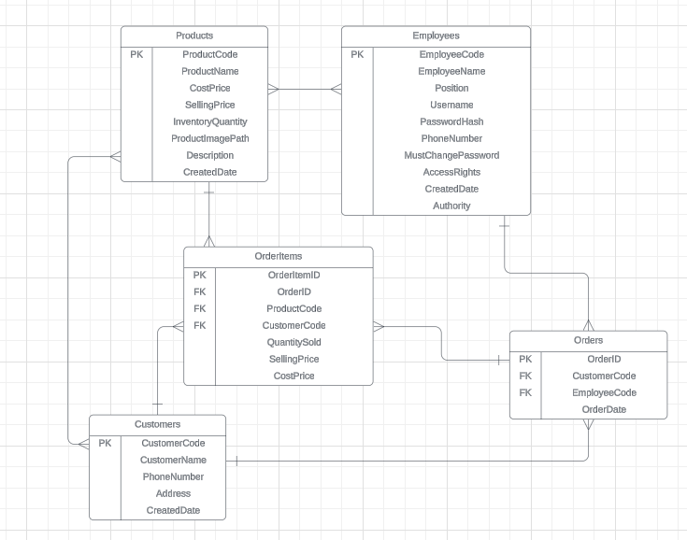

Diagram Analysis:

* One-to-Many Relationships:
* Products to OrderItems:
* Relationship Type: One-to-Many
* Purpose: One product can be included in multiple order items. This relationship is represented by the ProductCode foreign key in the OrderItems table, which references the ProductCode primary key in the Products table.
* Employees to Orders:
* Relationship Type: One-to-Many
* Purpose: One employee can handle multiple orders. This relationship is represented by the EmployeeCode foreign key in the Orders table, which references the EmployeeCode primary key in the Employees table.
* Customers to Orders:
* Relationship Type: One-to-Many
* Purpose: One customer can place multiple orders. This relationship is represented by the CustomerCode foreign key in the Orders table, which references the CustomerCode primary key in the Customers table.
* Orders to OrderItems:
* Relationship Type: One-to-Many
* Purpose: One order can contain multiple order items. This relationship is represented by the OrderID foreign key in the OrderItems table, which references the OrderID primary key in the Orders table.
* Customers to OrderItems:
* Relationship Type: One-to-Many
* Purpose: One customer can have multiple order items. This relationship is represented by the CustomerCode foreign key in the OrderItems table, which references the CustomerCode primary key in the Customers table.
* Products to OrderItems:
* Relationship Type: One-to-Many
* Purpose: One product can appear in multiple order items. This relationship ensures that product details are linked to multiple sales transactions via the ProductCode foreign key in OrderItems table.
* Many-to-Many Relationships (via associative tables):
* Products to Customers:
* Relationship Type: Many-to-Many (via Orders and OrderItems)
* Purpose: Multiple products can be purchased by multiple customers. This relationship is indirectly represented through the Orders and OrderItems tables, linking ProductCode in OrderItems to CustomerCode in Orders.
* Products to Employees:
* Relationship Type: Many-to-Many (via Orders and OrderItems)
* Purpose: Multiple products can be sold by multiple employees. This relationship is indirectly represented through the Orders and OrderItems tables, linking ProductCode in OrderItems to EmployeeCode in Orders.
* Customers to Employees:
* Relationship Type: Many-to-Many (via Orders)
* Purpose: Multiple customers can interact with multiple employees through their orders. This relationship is represented by the CustomerCode in Orders and EmployeeCode in Orders.

**1.1.4 Design the tables needed in the database, the columns corresponding to the attributes, and the data type for each column:**

* Create tables:

|  |  |
| --- | --- |
|  |  |

Figure 1-1: Create tables in database

* Relation diagram:

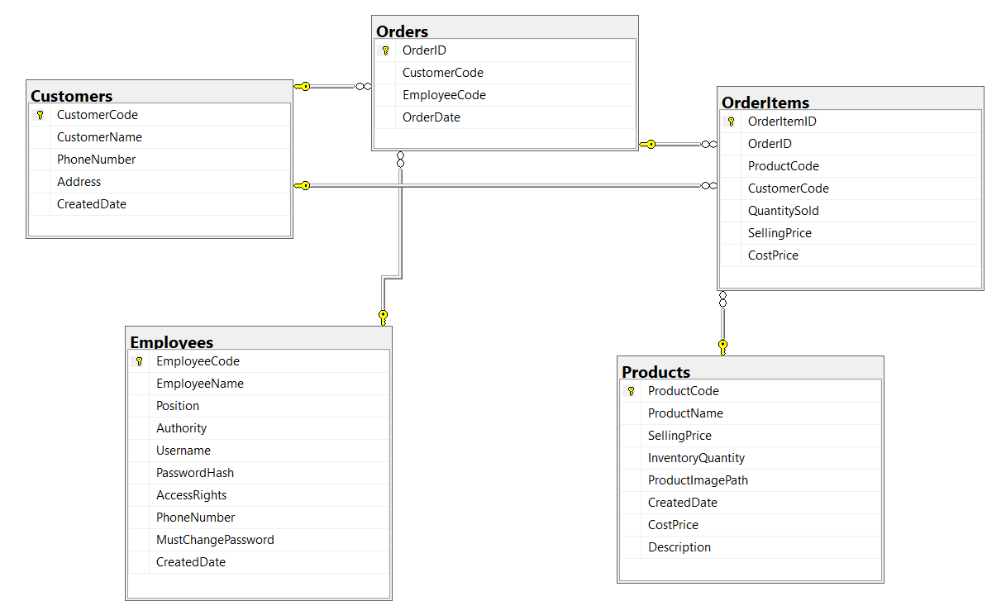

* Relationships:
* Orders to Customers:
  + Purpose: The Orders table is connected to the Customers table through the CustomerCode field, indicating which customer made a particular purchase.
* Orders to Employees:
  + Purpose: The Orders table is connected to the Employees table through the EmployeeCode field, indicating which employee processed the sale.
* OrderItems to Orders:
  + Purpose: The OrderItems table is linked to the Orders table via the OrderID field, indicating which order the items belong to.
* OrderItems to Products:
  + Purpose: The OrderItems table is linked to the Products table via the ProductCode field, indicating which product was sold.
* OrderItems to Customers:
  + Purpose: The OrderItems table is linked to the Customers table via the CustomerCode field, indicating which customer purchased the items.
* Analysis Diagram:
* Data Integrity:
* The use of primary keys (e.g., CustomerCode, ProductCode, EmployeeCode, OrderID, OrderItemID) ensures that each record is unique and easily identifiable.
* Referential Integrity:
* Foreign key relationships (e.g., CustomerCode in Orders referencing CustomerCode in Customers) enforce data consistency and integrity across related tables.
* Scalability and Flexibility:
* The structure allows for easy addition of new records and relationships, making it scalable to accommodate more data as the business grows.
* Security:
* Fields like PasswordHash and AccessRights in the Employees table indicate a focus on secure user authentication and access control.

🡺 This ERD efficiently models the database for a sales management system by clearly defining the relationships between key entities: Customers, Orders, OrderItems, Products, and Employees. It ensures data integrity, referential integrity, scalability, flexibility, and security across the system. This robust structure supports efficient sales management and facilitates the smooth operation of business processes.

* Insert data to the Products table:

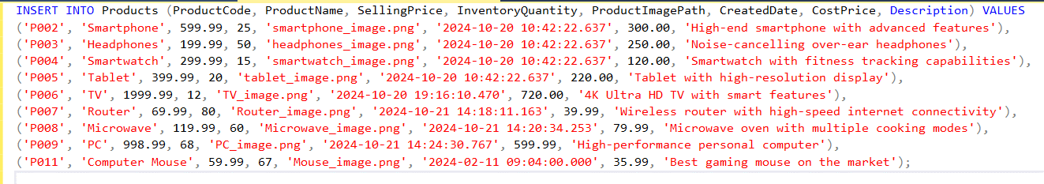Figure 1-2: Insert data into Products table

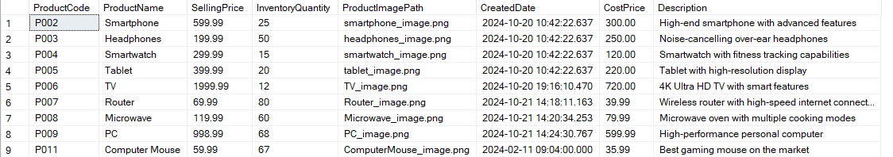Figure 1-3: Data in table Products

* Insert data to Customers table:

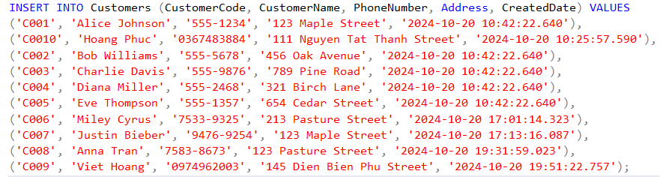

Figure 1-4: Insert data to Customers table

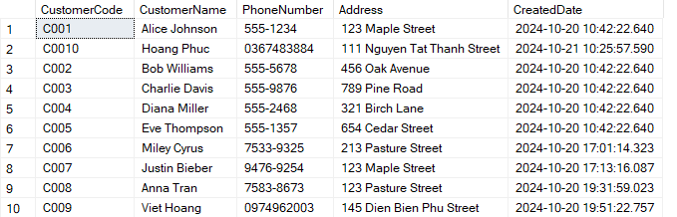

Fgiure 1-5: Data in table Customers

* Insert data to Employees table:

Fgiure 1-6: Insert data into Employees table

Fgiure 1-7: Data in Employees table

**1.1.5 Set up primary keys and foreign keys to ensure data integrity:**

a) Products Table

* Primary Key:
* ProductCode (PK): Ensures each product is uniquely identified.
* Columns:
* ProductName
* CostPrice
* SellingPrice
* InventoryQuantity
* ProductImagePath
* Description
* CreatedDate

b) Employees Table

* Primary Key:
* EmployeeCode (PK): Ensures each employee is uniquely identified.
* Columns:
* EmployeeName
* Position
* Authority
* Username
* PasswordHash
* PhoneNumber
* MustChangePassword
* AccessRights
* CreatedDate

c) Customers Table

* Primary Key:
* CustomerCode (PK): Ensures each customer is uniquely identified.
* Columns:
* CustomerName
* PhoneNumber
* Address
* CreatedDate

d) Orders Table

* Primary Key:
* OrderID (PK): Ensures each sale record is uniquely identified.
* Foreign Keys:
* EmployeeCode (FK): References Employees(EmployeeCode) to ensure each sale record links to a valid employee.
* CustomerCode (FK): References Customers(CustomerCode) to ensure each sale record links to a valid customer.
* Columns:
* OrderDate

e) OrderItems table

* Primary Key:
* OrderItemID (PK): Ensures each order record is uniquely identified.
* Foreign Key:
* EmployeeCode (FK): References Employees(EmployeeCode) to ensure each sale record links to a valid employee.
* CustomerCode (FK): References Customers(CustomerCode) to ensure each sale record links to a valid customer.
* OrderID (FK): References Orders(OrderID) to indicating which order the items belong to.
* Column:
* QuantitySold
* SellingPrice
* CostPrice

**1.1.6 Normalize the database to eliminate duplicate data and ensure data consistency:**

**1.1.6.1 Normalization definition:**

Normalization is the process of organizing data within a database to reduce redundancy and improve data integrity. It involves structuring a relational database according to a series of rules called "normal forms," which are aimed at ensuring that each piece of data is stored only once and that relationships between tables are clear.

**1.1.6.2 Purpose of normalization:**

* Eliminate Data Redundancy: Normalization divides large, complex tables into smaller, more focused ones, ensuring that each piece of data is stored only once, which reduces duplicate data and storage inefficiency.
* Improve Data Integrity: By organizing data into tables that are logically related, normalization helps to enforce data consistency and prevents anomalies during insertions, updates, and deletions.
* Simplify Data Maintenance: Normalized databases are easier to maintain since changes to the data are made in only one place, simplifying updates and improving the reliability of the data.
* Enhance Query Efficiency: By structuring data in a more logical and organized way, normalization often leads to more efficient querying and processing within the database, although excessive normalization can sometimes impact performance.
* Support Scalability: A well-normalized database is easier to scale and extend as business requirements change or expand, as it prevents a tangled structure that would be hard to modify.

**1.1.6.3 Types of Database Normalization:**

First Normal Form (1NF)

* Criteria:
* Each table has a primary key.
* Each column contains atomic (indivisible) values.
* Each column contains values of a single type.
* Each column should contain only a single value from the attribute domain.
* Application to my Entities:
* Products:
* Primary Key: ProductCode
* Columns: Each column contains atomic values, all of a single type, and only a single value from the attribute domain.
* Employees:
* Primary Key: EmployeeCode
* Columns: Each column contains atomic values, all of a single type, and only a single value from the attribute domain.
* Customers:
* Primary Key: CustomerCode
* Columns: Each column contains atomic values, all of a single type, and only a single value from the attribute domain.
* Orders:
* Primary Key: OrderID
* Foreign Keys: EmployeeCode, CustomerCode
* Columns: Each column contains atomic values, all of a single type, and only a single value from the attribute domain.
* OrderItems:
* Primary Key: OrderItemID
* Foreign Keys: ProductCode, OrderID, CustomerCode
* Columns: Each column contains atomic values, all of a single type, and only a single value from the attribute domain.

Second Normal Form (2NF)

* Criteria:
* Must meet all criteria of 1NF.
* Eliminate partial dependencies, where non-key attributes are dependent on part of the primary key in composite key tables.
* Application to my Entities:
* Since all primary keys in my tables are single-column primary keys (ProductCode, EmployeeCode, CustomerCode, OrderID, OrderItemID), there are no partial dependencies. Therefore, all tables are already in 2NF.

Third Normal Form (3NF)

* Criteria:
* Must meet all criteria of 2NF.
* Eliminate transitive dependencies, where non-key attributes are dependent on other non-key attributes.
* Application to my Entities:
* Products:
* No transitive dependencies. Each attribute is functionally dependent on the primary key (ProductCode).
* Employees:
* No transitive dependencies. Each attribute is functionally dependent on the primary key (EmployeeCode).
* Customers:
* No transitive dependencies. Each attribute is functionally dependent on the primary key (CustomerCode).
* Orders:
* No transitive dependencies. Each attribute is functionally dependent on the primary key (OrderID).
* OrderItems:
* No transitive dependencies. Each attribute is functionally dependent on the primary key (OrderItemID).

🡺 These tables, adhering to 1NF, 2NF, and 3NF, ensure data integrity, minimize redundancy, and support efficient data management within the sales management system. This robust structure enables effective tracking and analysis across products, employees, customers, orders, and order items.

**1.2 Produce a comprehensive design for a fully-functional system, which includes interface and output designs, data validations and data normalisation (M1)**

**1.2.1 Produce mockups or wireframes for user interfaces (UI) based on user roles and functionalities by Balsamiq Wireframes software:**

What is Balsamiq Wireframes?



Figure 1-8: Balsamiq Wireframes

Balsamiq Wireframes is a user interface design tool for creating wireframes.

I can use it to generate digital sketches of my idea or concept for an application or website, to facilitate discussion and understanding before any code is written. The completed wireframes can be used for user testing, clarifying my vision, getting feedback from stakeholders, or getting approval to start development.

**1.2.1.1 Login form:**

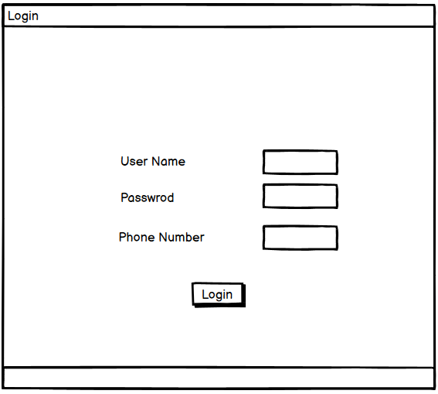

Figure 1-9: Login form

* Login Form Design
* Elements in the Login Form:
* Title:
  + The form is titled "Login," which clearly indicates its purpose to users.
* Input Fields:
* Username: A text box where users enter their username.
* Password: A text box where users enter their password. Typically, this text box would mask the entered characters to maintain security.
* Phone Number: A text box for entering the phone number, used for additional verification. This helps in multi-factor authentication, adding an extra layer of security.
* Login Button:
  + A button labeled "Login." When clicked, this button triggers the login process.
* Layout:
* The layout is simple and user-friendly, ensuring that the user can easily find and enter the required information.
* Alignment: The input fields are typically aligned vertically to provide a clean and organized look.
* Labels: Each input field has a clear label indicating what information is required (e.g., "Username," "Password," "Phone Number").

#### **1.2.1.2 Admin form:**

a) Product management tab:

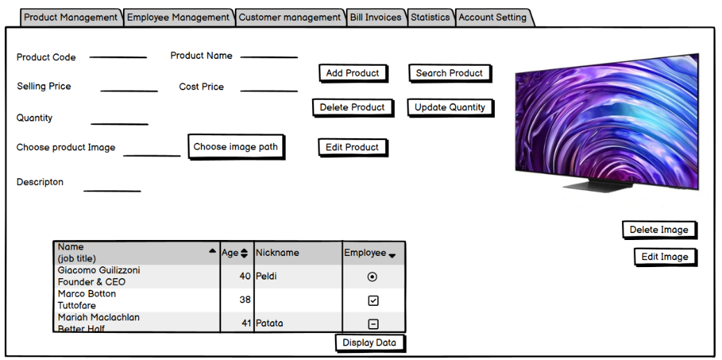

Figure 1-10: Product management tab

* Product Management Tab Design
* Input Fields:
* Product Code: Text box for entering or displaying the unique product code.
* Product Name: Text box for entering or displaying the product name.
* Selling Price: Text box for entering or displaying the selling price of the product.
* Cost Price: Text box for entering or displaying the cost price of the product.
* Quantity: Text box for entering or displaying the inventory quantity of the product.
* Choose Product Image: Button labeled "Choose image path" for selecting and displaying an image of the product.
* Description: Text box for entering or displaying a detailed description of the product.
* Action Buttons:
* Add Product: Adds a new product to the database using the entered details.
* Search Product: Searches for a product based on the entered criteria.
* Delete Product: Deletes the selected product from the database.
* Update Quantity: Updates the inventory quantity of the selected product.
* Edit Product: Edits the details of the selected product.
* Delete Image: Deletes the image associated with the selected product.
* Edit Image: Edits the image associated with the selected product.
* Product Image:
* Display area for the product image (e.g., an image of a television).
* Product List Table:
* A table displaying detailed information about products, such as Product Code, Product Name, Selling Price, Cost Price, Quantity, and Description.

b) Employees management tab:

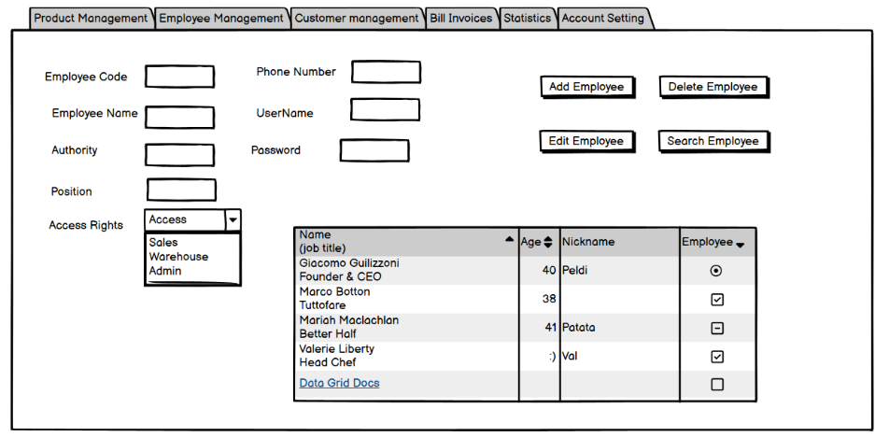

Figure 1-11: Employees management tab

* Employee Management Tab Layout
* Input Fields:
* Employee Code: Text box for entering or displaying the unique employee code.
* Employee Name: Text box for entering or displaying the employee's name.
* Authority: Text box for entering or displaying the employee's authority level.
* Position: Text box for entering or displaying the employee's position.
* Phone Number: Text box for entering or displaying the employee's phone number.
* Username: Text box for entering or displaying the employee's username.
* Password: Text box for entering or displaying the employee's password.
* Dropdown Menu:
* Access Rights: Dropdown menu with options such as Sales, Warehouse, and Admin to assign specific access rights to the employee.
* Action Buttons:
* Add Employee: Button to add a new employee to the system.
* Delete Employee: Button to delete an existing employee from the system.
* Edit Employee: Button to edit the details of an existing employee.
* Search Employee: Button to search for an employee based on the entered criteria.
* Employee List Table:
* A table displaying detailed information about employees

c) Customer management tab:

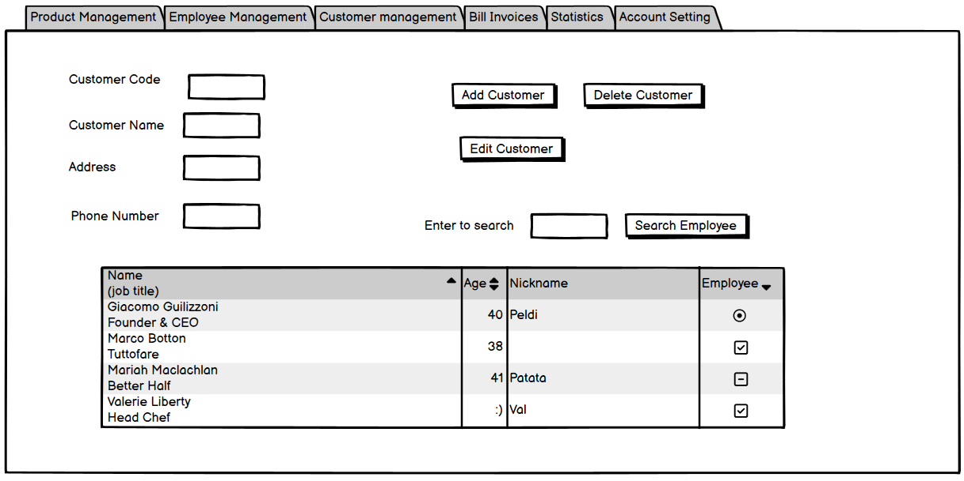

Figure 1-12: Customer management tab

* Customer Management Tab Layout
* Input Fields:
* Customer Code: Text box for entering or displaying the unique customer code.
* Customer Name: Text box for entering or displaying the customer's name.
* Address: Text box for entering or displaying the customer's address.
* Phone Number: Text box for entering or displaying the customer's phone number.
* Action Buttons:
* Add Customer: Button to add a new customer to the system.
* Delete Customer: Button to delete an existing customer from the system.
* Edit Customer: Button to edit the details of an existing customer.
* Search Employee: Button to search for an employee based on the entered criteria.
* Customer List Table:
* A table displaying detailed information about customers

d) Statistics tab:

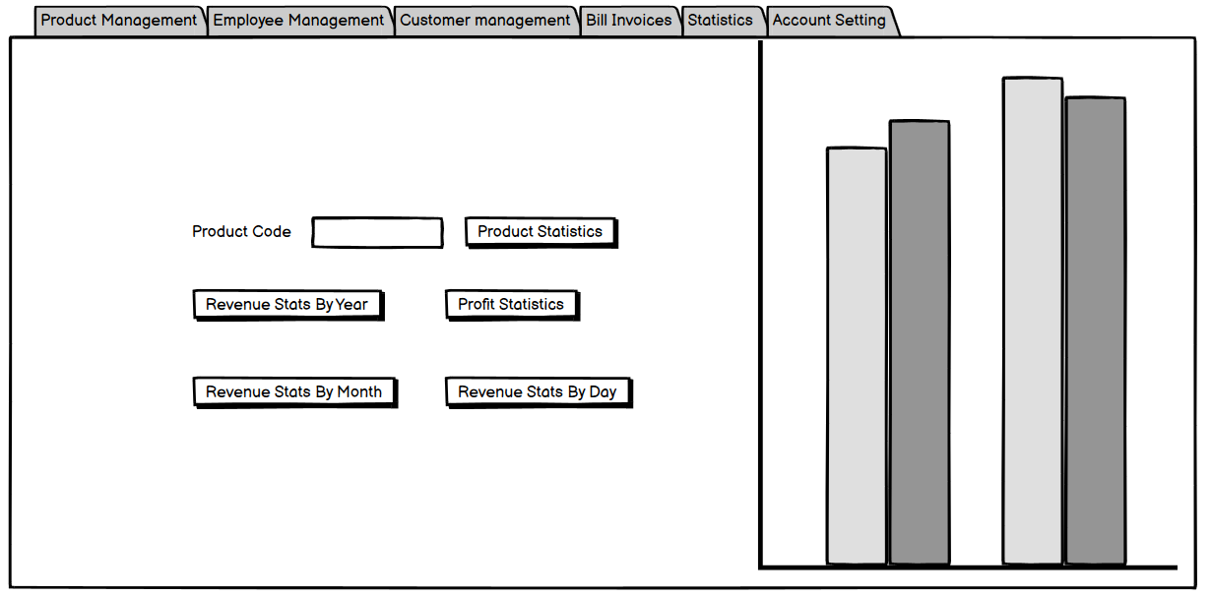

Figure 1-13: Statistics tab

* Statistics Tab Layout
* Main Section:
* Text Input Field:
  + Product Code: A text box where users can enter a product code to generate specific statistics related to that product.
* Action Buttons:
* Product Statistics: Button to generate and display statistics for a specific product based on the entered product code.
* Revenue Stats By Year: Button to generate and display annual revenue statistics.
* Revenue Stats By Month: Button to generate and display monthly revenue statistics.
* Revenue Stats By Day: Button to generate and display daily revenue statistics.
* Profit Statistics: Button to generate and display profit statistics.
* Chart Display:
* Bar Chart: On the right side of the interface, a bar chart is displayed, visualizing the statistical data generated by the selected action buttons. The chart can represent various data points such as product statistics, revenue, and profit.

e) Account setting tab:

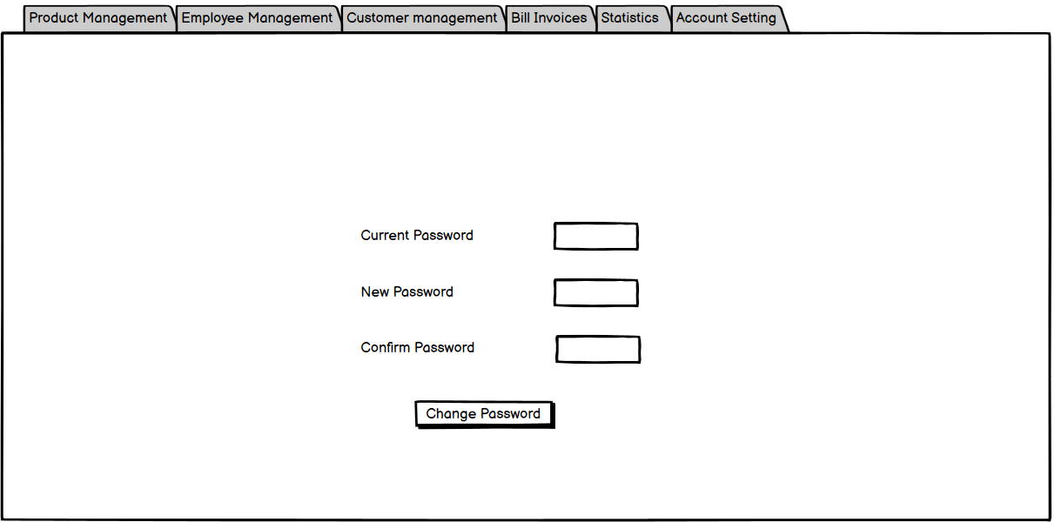

Figure 1-14: Account setting tab

* Layout:
* Input Fields:
* Current Password: Text box for entering the current password of the administrator.
* New Password: Text box for entering the new password the administrator wishes to set.
* Confirm Password: Text box for re-entering the new password to confirm it.
* Action Button:
* Change Password: Button to submit the new password change request.

f) Sales invoices tab:

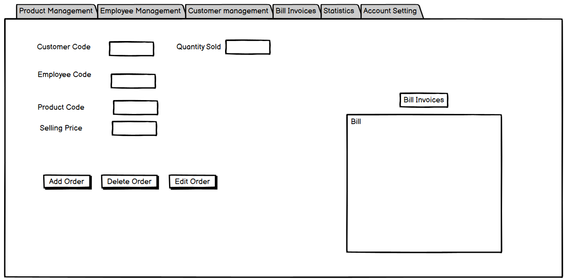

Figure 1-15: Sales invoices tab

* Sales Invoices Tab Layout
* Main Section:
* Input Fields:
* Customer Code: A text box for entering the unique code of the customer making the purchase.
* Employee Code: A text box for entering the code of the employee handling the sale.
* Product Code: A text box for entering the unique product code of the items being sold.
* Selling Price: A text box for entering the selling price of the product.
* Quantity Sold: A text box for entering the quantity of the product being sold.
* Action Buttons:
* Add Order: Button to add a new sales order to the invoice.
* Delete Order: Button to delete an existing order from the invoice.
* Edit Order: Button to edit the details of an existing order.
* Bill Invoices Section:
* A designated area labeled "Bill Invoices" with a box labeled "Bill," where invoice details are likely displayed and managed.

**1.2.1.3 Sales staff form:**

While the Sales Staff form's Product Management tab provides essential tools for managing product information, it lacks the more advanced administrative, statistical, and security features found in the Admin form. This ensures that sales staff can focus on their primary tasks without access to more sensitive administrative functions.

a) Product management tab:

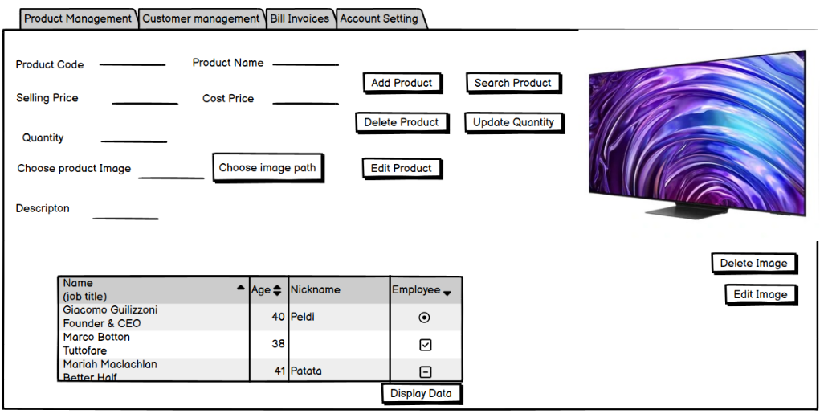

Figure 1-16: Product management tab in Sales staff form

The Product Management tab in the Sales Staff form functions similarly to the Product Management tab in the Admin form.

b) Customer management tab:

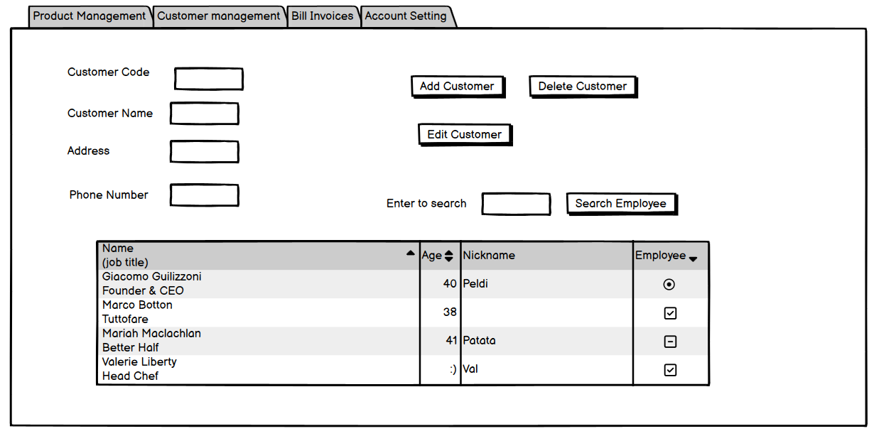

Figure 1-17: Customer management tab in Sales staff form

The Customer Management tab in the Sales Staff form functions similarly to the Customer Management tab in the Admin form.

c) Sales invoices tab:

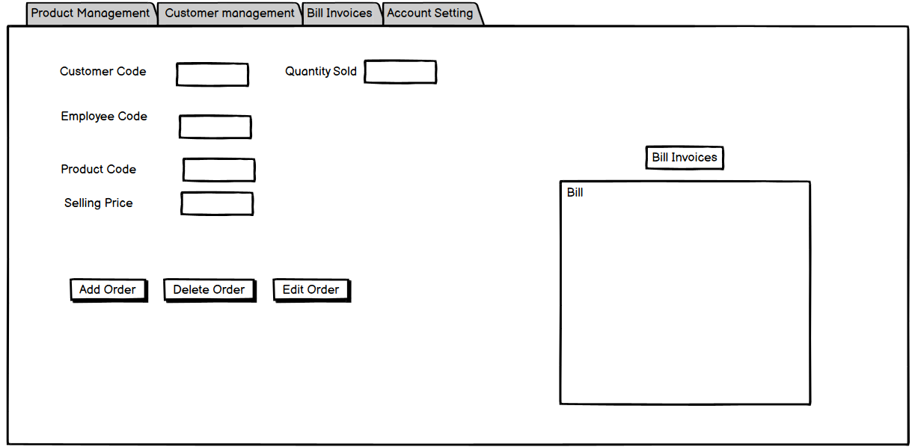

Figure 1-18: Sales invoices tab in Sales staff form

The Sales Invoices tab in the Sales Staff form functions similarly to the Sales Invoices tab in the Admin form.

d) Account setting tab:

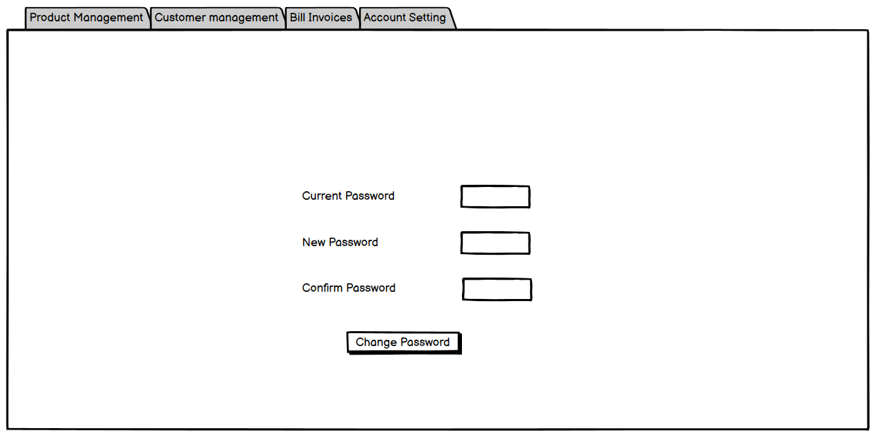

Figure 1-19: Account setting tab in Sales staff form

The Account Setting tab in the Sales Staff form functions similarly to the Account Setting tab in the Admin form.

**1.2.1.4 Warehouse staff form:**

The Warehouse Staff form excludes advanced administrative and reporting functions found in the Admin form. This limitation ensures that warehouse staff focus on their specific tasks without accessing features beyond their role, which helps maintain data integrity and security within the system.

a) Product management tab:

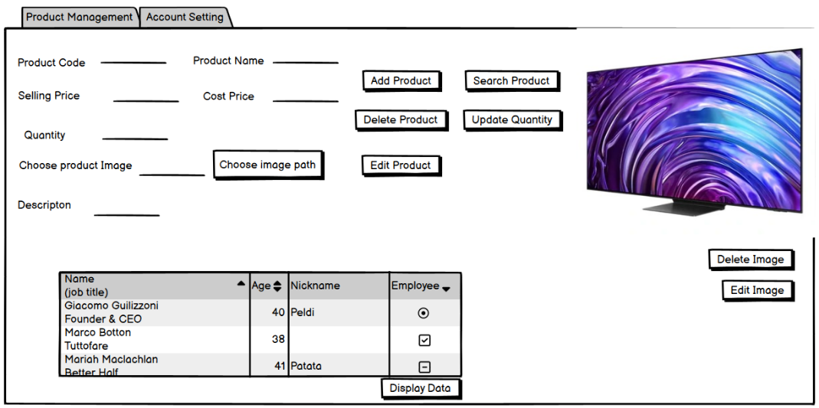

Figure 1-20: Product management tab in Sales staff form

This tab allows warehouse staff to manage products, including adding, editing, deleting, and updating inventory quantities. They can also handle product images and descriptions.

b) Account setting tab:

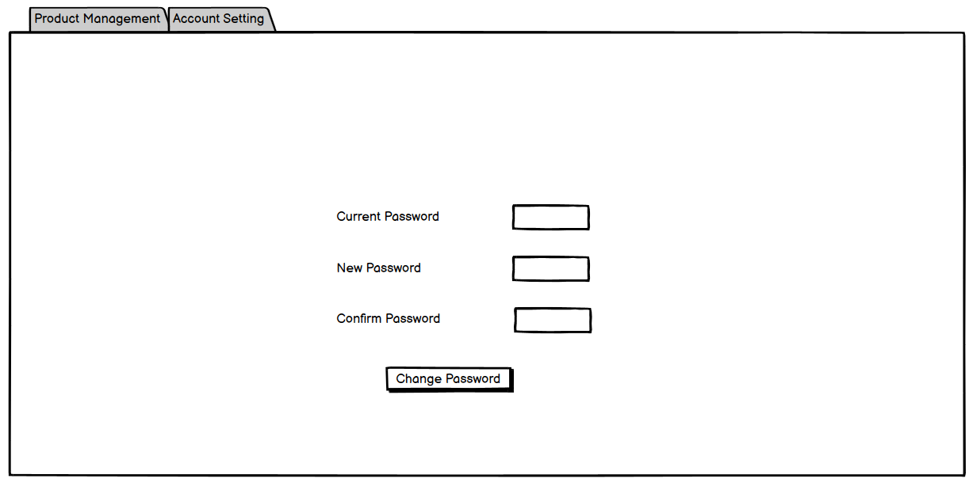

Figure 1-21: Account setting tab in Sales staff form

This tab is for managing personal account settings, specifically for changing passwords to ensure the security of their accounts.

**1.2.2 Produce data validation rules to guarantee the accuracy and validity of data entered into the system:**

Data Validation is the process of ensuring that a program or system only accepts data that is correct, meaningful, and useful. It involves checking the accuracy and quality of data before it is processed or stored, thereby preventing errors and maintaining data integrity

a) Product management:

* Validation Rules:
* ProductCode:
* Must be unique: Ensure that each product code is distinct and not duplicated within the database.
* Length between 1 and 20 characters: Enforce that the product code is neither too short nor too long, fitting within the specified range.
* ProductName:
* Cannot be null or empty: Ensure that every product has a name provided.
* Maximum length of 100 characters: Prevent exceedingly long product names.
* CostPrice and SellingPrice:
* Must be numeric values: Ensure that these fields accept only numbers.
* Greater than 0: Prevent prices from being zero or negative, which are invalid for pricing.
* InventoryQuantity:
* Must be an integer: Ensure that inventory quantities are whole numbers.
* Greater than or equal to 0: Prevent negative inventory counts.
* ProductImagePath:
* Valid file path or URL: Ensure that the image path provided is correctly formatted.
* Maximum length of 255 characters: Prevent exceedingly long file paths or URLs.
* Description:
* Maximum length of 255 characters: Ensure that the description is concise and within the character limit.
* CreatedDate:
* Must be a valid date and time: Ensure that the date provided is correctly formatted and valid.

b) Employee Management

* Validation Rules:
* EmployeeCode:
* Must be unique: Ensure that each employee code is distinct and not duplicated within the database.
* Length between 1 and 20 characters: Enforce that the employee code is neither too short nor too long, fitting within the specified range.
* EmployeeName:
* Cannot be null or empty: Ensure that every employee has a name provided.
* Maximum length of 100 characters: Prevent exceedingly long employee names.
* Position and Authority:
* Cannot be null or empty: Ensure that both fields are provided.
* Maximum length of 50 characters each: Prevent exceedingly long values.
* Username:
* Must be unique: Ensure that each username is distinct.
* Cannot be null or empty: Ensure that every employee has a username.
* Maximum length of 50 characters: Prevent exceedingly long usernames.
* PasswordHash:
* Cannot be null or empty: Ensure that a password hash is provided.
* Securely hashed: Use a secure hashing algorithm like BCrypt.
* PhoneNumber:
* Valid phone number format: Ensure that the phone number follows a standard format.
* Maximum length of 15 characters: Prevent exceedingly long phone numbers.
* AccessRights:
* Cannot be null or empty: Ensure that access rights are assigned.
* Predefined values: Limit to predefined values like Admin, Sales, Warehouse.
* CreatedDate:
* Must be a valid date and time: Ensure that the date provided is correctly formatted and valid.

c) Customer Management

* Validation Rules:
* CustomerCode:
* Must be unique: Ensure that each customer code is distinct and not duplicated within the database.
* Length between 1 and 20 characters: Enforce that the customer code is neither too short nor too long, fitting within the specified range.
* CustomerName:
* Cannot be null or empty: Ensure that every customer has a name provided.
* Maximum length of 100 characters: Prevent exceedingly long customer names.
* PhoneNumber:
* Valid phone number format: Ensure that the phone number follows a standard format.
* Maximum length of 15 characters: Prevent exceedingly long phone numbers.
* Address:
* Maximum length of 255 characters: Ensure that the address is concise and within the character limit.
* CreatedDate:
* Must be a valid date and time: Ensure that the date provided is correctly formatted and valid.

d) Orders table:

* Validation Rules:
* OrderID:
* Must be unique: Each OrderID should be distinct and not duplicated within the table.
* Auto-incremented: Automatically incremented by the database.
* CustomerCode:
* Must exist: Referenced CustomerCode must exist in the Customers table.
* Cannot be NULL: CustomerCode should always have a value.
* EmployeeCode:
* Must exist: Referenced EmployeeCode must exist in the Employees table.
* Cannot be NULL: EmployeeCode should always have a value.
* OrderDate:
* Must be a valid date: OrderDate should be in a valid date format.
* Cannot be NULL: OrderDate should always have a value.

e) OrderItems table:

* Validation Rules:
* OrderItemID:
* Must be unique: Each OrderItemID should be distinct and not duplicated within the table.
* Auto-incremented: Automatically incremented by the database.
* OrderID:
* Must exist: Referenced OrderID must exist in the Orders table.
* Cannot be NULL: OrderID should always have a value.
* ProductCode:
* Must exist: Referenced ProductCode must exist in the Products table.
* Cannot be NULL: ProductCode should always have a value.
* CustomerCode:
* Must exist: Referenced CustomerCode must exist in the Customers table.
* Cannot be NULL: CustomerCode should always have a value.
* QuantitySold:
* Must be an integer: QuantitySold should be a whole number.
* Greater than 0: QuantitySold should be a positive integer.
* SellingPrice:
* Must be numeric: SellingPrice should be a numeric value.
* Greater than 0: SellingPrice should be a positive value.
* CostPrice:
* Must be numeric: CostPrice should be a numeric value.
* Greater than 0: CostPrice should be a positive value.

**1.2.3 Test and optimize data queries to retrieve data efficiently:**

**1.2.3.1 Testing of Data Queries:**

This part focuses on testing the data queries for the five key tables in my Sales Management System: Products, Employees, Customers, Orders, and OrderItems. The goal is to ensure that my queries retrieve accurate and relevant data efficiently. By performing these tests, I aim to guarantee the integrity and reliability of the system.

Purpose: The purpose of this testing is to validate the queries used to fetch data from the system, ensuring they meet the expected criteria and return correct results. This includes confirming the integrity of data, improving query performance, and ensuring the system operates effectively under different scenarios.

a) Products Table:

* 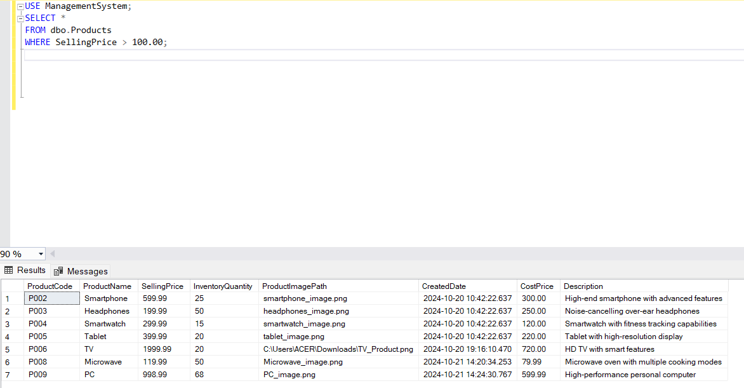Objective: To retrieve and verify product details.
* Query: Retrieve all products with a selling price greater than a specified value.
* Purpose: To check that the system correctly filters products based on their selling price.
* 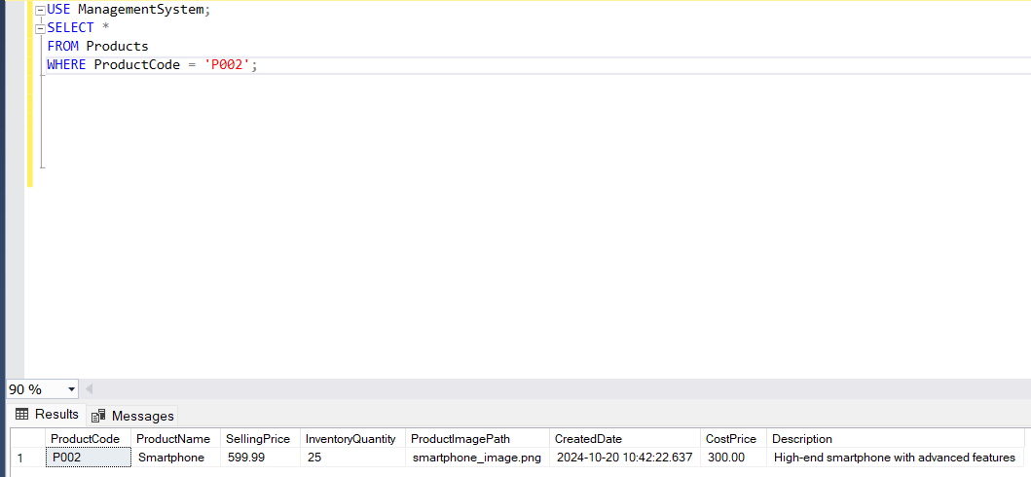Query: Search for a product by its product code.
* Purpose: To ensure the system accurately retrieves product details using a specific product code

b) Employees Table:

* Objective: To retrieve and verify employee details.
* Query: Retrieve all employees with a specific position.
* Purpose: To validate that the system can filter employees based on their job position.

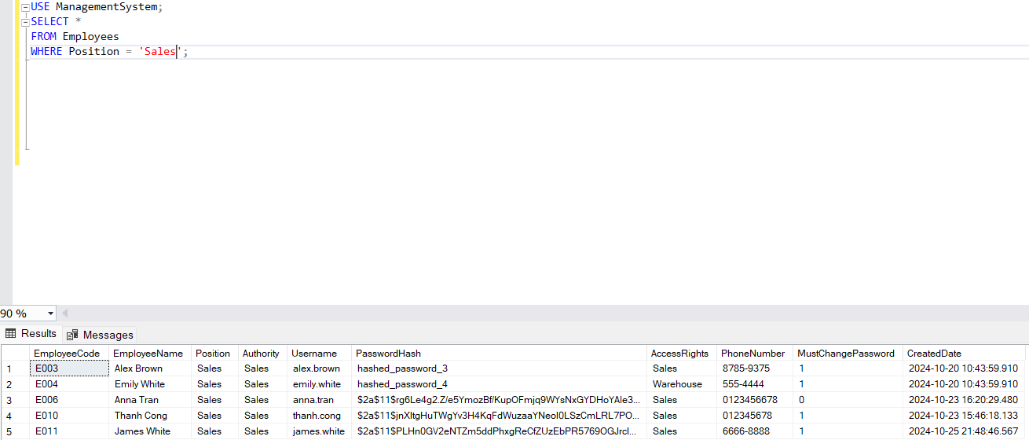

* Query: Search for an employee by their employee code.
* Purpose: To confirm that the system accurately retrieves employee details using a specific employee code.

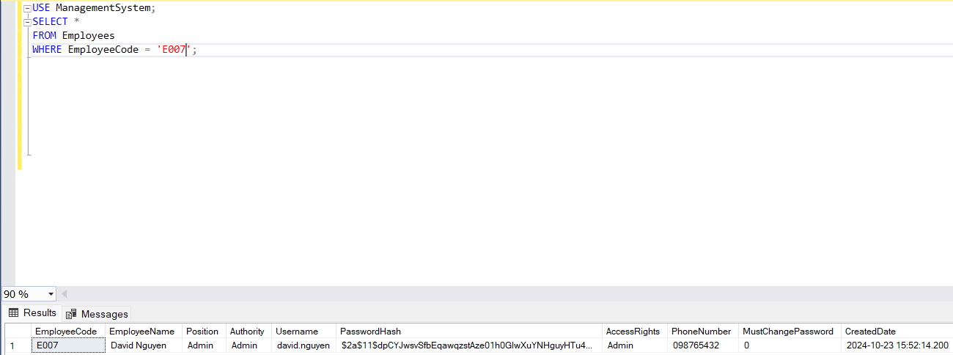

c) Customers Table:

* 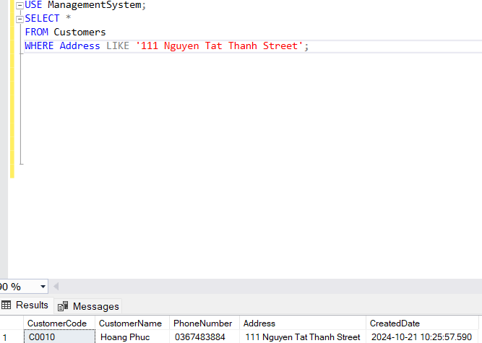Objective: To retrieve and verify customer details.
* Query: Retrieve all customers from a specific city.
* Purpose: To ensure the system can accurately filter customers based on their address.
* 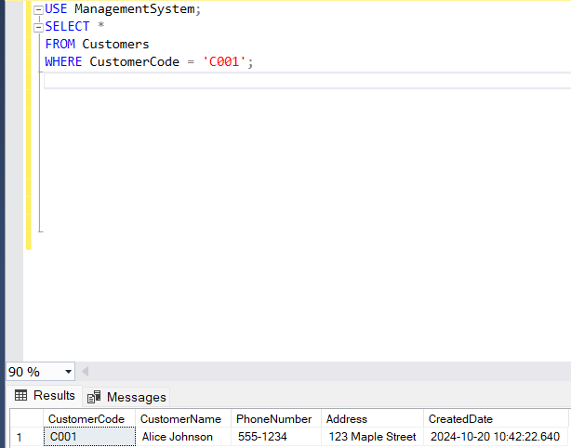Query: Search for a customer by their customer code.
* Purpose: To validate that the system retrieves customer details using a specific customer code.

d) Orders Table:

* 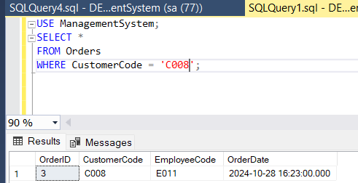Objective: To retrieve and verify order details.
* Query: Retrieve all orders placed by a specific customer.
* Purpose: To check that the system correctly identifies all orders made by a specific customer.
* 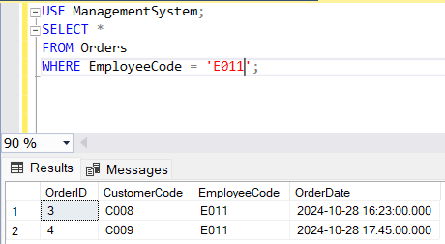Query: Retrieve all orders processed by a specific employee.
* Purpose: To ensure that the system accurately tracks orders processed by a specific employee.

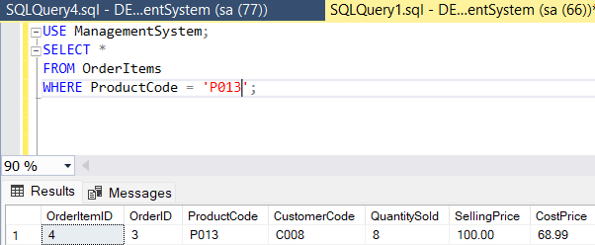e) OrderItems Table:

* Query: Retrieve all order items for a specific product.
* Purpose: To ensure the system can accurately identify order items for a specific product.

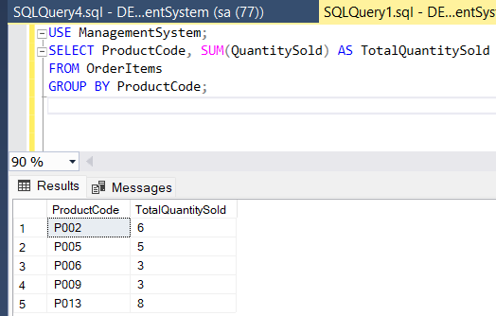

* Query: Retrieve the total quantity sold for each product.
* Purpose: To verify that the system correctly calculates the total quantity sold for each product.

**1.2.3.2 Optimize Data Queries:**

In the context of developing a database-backed sales management system, it is crucial to optimize data queries for efficient data retrieval. Optimizing database performance ensures that the application remains responsive, especially as the data grows over time. This report analyzes key optimization strategies applied to a relational database system comprising five primary tables: Customers, Products, Employees, Orders, and OrderItems. Each strategy is chosen based on the structural and functional requirements of the application and aims to streamline data access, minimize redundant processing, and improve overall system responsiveness.

a) Indexing:

Indexing is one of the most fundamental methods of optimizing database performance. An index on a column or a set of columns allows the database engine to locate and retrieve data without scanning every row in a table, which significantly reduces query time.

* Primary and Foreign Key Indexes: Primary keys are automatically indexed, which facilitates efficient row identification. For foreign keys, explicitly creating indexes on these columns speeds up joins between tables by allowing the database to locate referenced rows quickly. In this system, indexing foreign keys like CustomerCode in the Orders table and ProductCode in the OrderItems table is essential since these columns are frequently used in join operations.
* Composite Indexes: When queries involve multiple columns for filtering or sorting, composite indexes enhance performance by allowing the database to search through combined values. For instance, in the Orders table, a composite index on (EmployeeCode, OrderDate) can optimize queries that retrieve all orders by a specific employee within a particular time frame. Without this, the query would have to perform additional scans to filter the data by both columns.

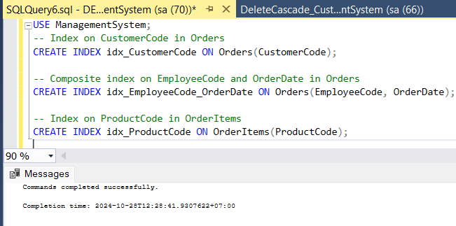

Figure 1-22: Primary and Foreign Key Indexes

Testing:

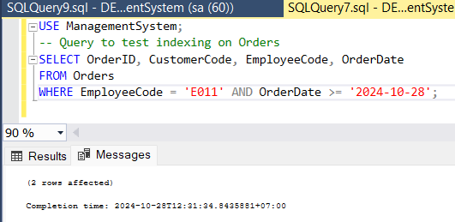

Figure 1-23: Composite Indexes

🡺 The purpose of these indexes is to improve query response times, reduce CPU usage, and optimize storage access by minimizing full table scans. This is especially critical in scenarios where the application queries large datasets or performs frequent data joins, as seen in a sales management system.

b) Optimizing Foreign Key Constraints:

Foreign key constraints maintain data integrity by ensuring that references between tables are valid. They also impact performance, especially when dealing with related records.

* ON DELETE CASCADE / SET NULL: Defining cascading actions, such as ON DELETE CASCADE, ensures that associated records in related tables are deleted automatically when a primary record is deleted. For example, if a customer record in Customers is deleted, all related orders in Orders can also be deleted. Alternatively, setting ON DELETE SET NULL can preserve historical data in the Orders table while removing sensitive customer information. This approach enhances both data integrity and performance by automating the handling of related data, reducing the complexity of individual delete operations.

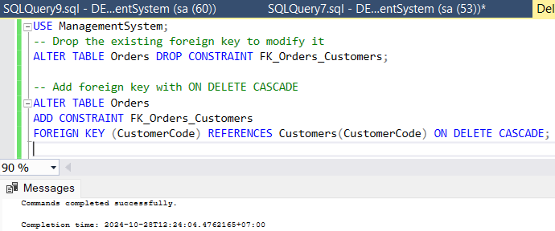

Figure 1-24: ON DELETE CASCADE / SET NULL

Testing Cascading Deletes: Delete a record from the Customers table

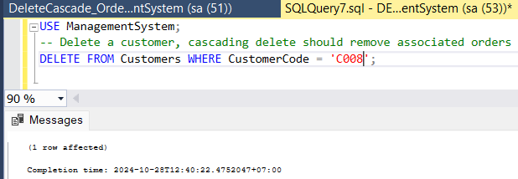

Figure 1-25: Testing Cascading Deletes

All associated orders in Orders are also deleted automatically:

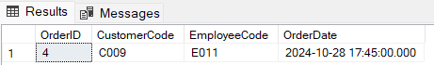

Figure 1-26: Results

🡺 By implementing these constraints, the system reduces the need for manual database management of related records, simplifying code and decreasing the likelihood of orphaned data that could result in inaccurate reporting or processing errors.

c) Selective Column Retrieval:

Using SELECT statements with specific columns rather than SELECT * is a simple yet effective optimization method. Selecting only the necessary columns minimizes the amount of data transferred from the database to the application, which reduces both memory usage and data retrieval time.

* For instance, when querying order details from the Orders table, retrieving only OrderID, CustomerCode, and OrderDate is often sufficient. This approach avoids unnecessary data transfer and results in faster processing, particularly when multiple tables are involved in the query.

🡺 The purpose of this selective retrieval is to streamline query performance, optimize network bandwidth, and improve application responsiveness. It also leads to better resource management on both the database server and the client side, which is crucial in large-scale or high-frequency applications.

d) Stored Procedures for Complex Queries:

Stored procedures are precompiled SQL queries that improve query performance by reducing the time needed to parse and compile SQL commands. They are particularly useful for complex queries involving multiple tables and calculations.

* Example: A stored procedure, sp_GetOrderDetails, can retrieve comprehensive order information by joining multiple tables. Instead of parsing and optimizing the query each time it is executed, the database can reuse the stored procedure’s execution plan, resulting in faster execution.

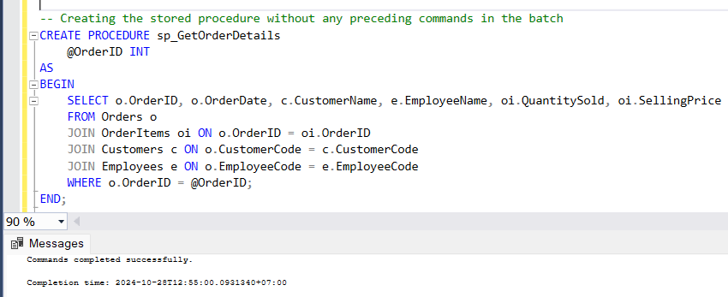

Figure 1-27: Stored Procedures for Complex Queries

Testing the Stored Procedure: Execute the stored procedure

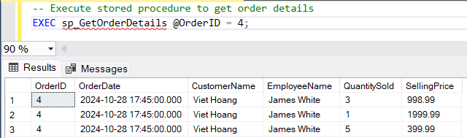

Figure 1-28: Testing the Stored Procedure

Stored procedures also encapsulate business logic within the database, enhancing security by limiting direct access to the tables. This encapsulation prevents unauthorized modifications and helps maintain a consistent application structure.

🡺 The primary purpose of stored procedures is to boost performance in frequently executed or complex queries, enhance data security, and simplify maintenance by centralizing logic within the database.

e) Data Type Optimization:

Choosing the appropriate data types for each column optimizes both storage and query performance. In this database, using data types that align closely with the data being stored not only reduces storage requirements but also speeds up data retrieval by minimizing processing overhead.

* Optimal Numeric Precision: Using DECIMAL(10, 2) for prices is appropriate for most financial data, ensuring accuracy without unnecessary precision. Storing numeric values with

excessive precision would increase storage requirements and processing time for calculations.

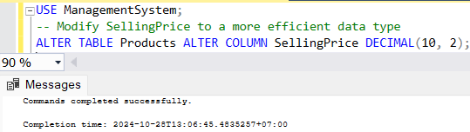

Figure 1-29: Optimal Numeric Precision

🡺 By employing optimal data types, the database reduces storage and query time, directly contributing to improved performance. This approach is especially relevant in columns with frequently updated data, as reduced data sizes lead to faster write operations.

f) Caching Strategies:

Caching improves query performance by storing frequently accessed data in memory, eliminating the need to repeatedly query the database. Implementing caching, especially for read-heavy data, can significantly reduce load times and database workload.

* Materialized Views: Materialized views are precomputed views that store the results of a complex query. For instance, a materialized view for daily sales totals would avoid repeated aggregation operations, significantly improving the speed of reporting queries.
* Database Caching: Database caching solutions can further reduce the number of redundant database queries, particularly useful for data that does not change frequently.

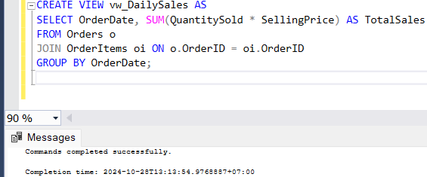

Figure 1-30: Caching Strategies

Testing the View: Use the view for daily sales reporting

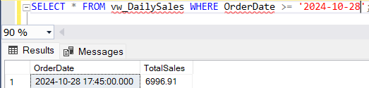

Figure 1-31: Testing the View

Caching enhances user experience by speeding up data retrieval, reduces resource strain on the database server, and ensures that high-demand data is available with minimal latency.

g) Batch Processing:

Batch processing reduces the overhead of individual transactions by executing them as a single batch. This approach is particularly useful for data modification operations that affect multiple rows.

* For instance, inserting or updating multiple customers in Customers table can be grouped into a batch operation, which reduces transaction commit overhead and optimizes database lock handling. Batch processing enhances performance by minimizing network traffic and maximizing the efficiency of data manipulation operations.

Test:

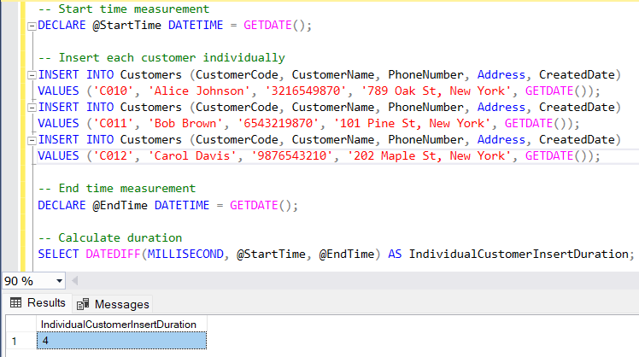The image show the results of each customer insert individually, indicating of 4 milliseconds

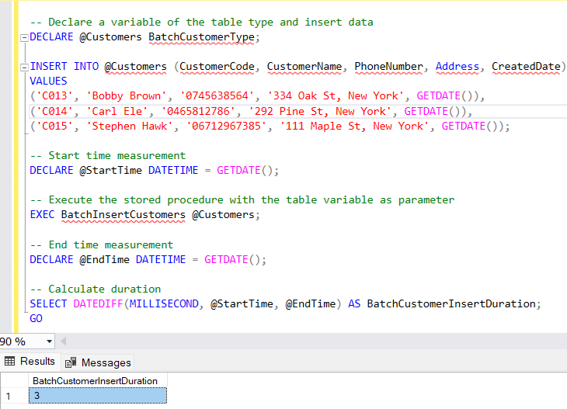So as you can see, the image shows the result of the batch insert operation, indicating a duration of 3 milliseconds for the batch customer insert.

🡺 The purpose of batch processing is to improve the efficiency of large data modifications, decrease network load, and optimize the database’s ability to handle concurrent operations.

Conclusion

The optimization strategies outlined in this report focus on improving data retrieval efficiency, enhancing system responsiveness, and ensuring data integrity in the sales management system’s database. By applying indexing, optimizing foreign key constraints, and implementing caching and batch processing, the system can maintain high performance under a growing workload. Adhering to these strategies will enable the application to serve users effectively, handle complex queries smoothly, and remain scalable for future growth.

**CHAPTER 2: Develop a fully-functional relational database system, based on an existing system design(L02)**

**2.1 Develop the database system with evidence of user interface, output and data validations, and querying across multiple tables (P2)**

**2.1.1 Develop a user interface (UI) for users to interact with the database**

**2.1.1.1 Login form:**



Figure 2-1: Login form

**2.1.1.2 Admin form:**

a) Product management tab:

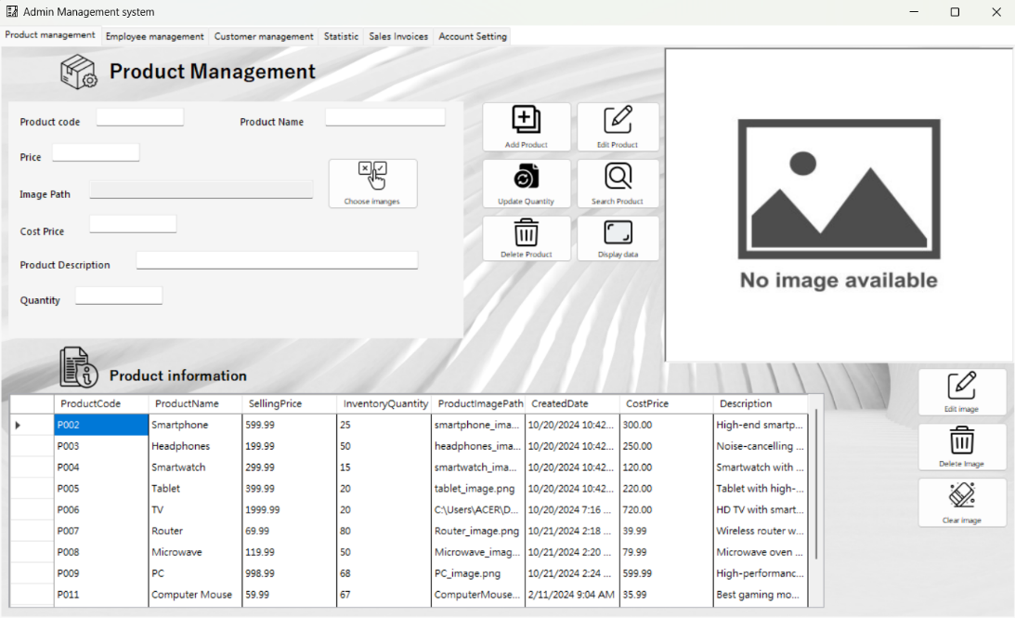

Figure 2-2: Product management tab in Admin form

The Product Management tab is a crucial component of the Admin Management System, providing administrators with robust capabilities to manage product information efficiently. This tab is designed to facilitate comprehensive product management, including adding, editing, deleting, and searching for products, as well as updating inventory quantities and managing product images.

Features and Components:

* Product Information Fields:
* Product Code: A unique identifier for each product.
* Product Name: The name of the product.
* Selling Price: The price at which the product is sold.
* Inventory Quantity: The current stock level of the product.
* Product Image Path: The file path to the product’s image.
* Cost Price: The cost of acquiring the product.
* Product Description: A detailed description of the product, highlighting its features and specifications.
* Functionality Buttons:
* Add Product: Allows administrators to add new products to the inventory. Clicking this button will save the entered product details into the system.
* Edit Product: Enables the modification of existing product details. Administrators can update information such as name, price, description, and inventory levels.
* Delete Product: Removes a selected product from the inventory.
* Update Inventory: Adjusts the inventory quantity for specific products when importing or selling goods.
* Search Product: Facilitates searching for products using criteria such as product code, name, or other relevant keywords.
* Product Data Display:
* The lower section of the tab features a DataGridView that displays the list of products along with their details. This table includes columns for Product Code, Product Name, Selling Price, Inventory Quantity, Product Image Path, Created Date, Cost Price, and Description. It allows administrators to easily view and manage product information.

b) Employees management tab:

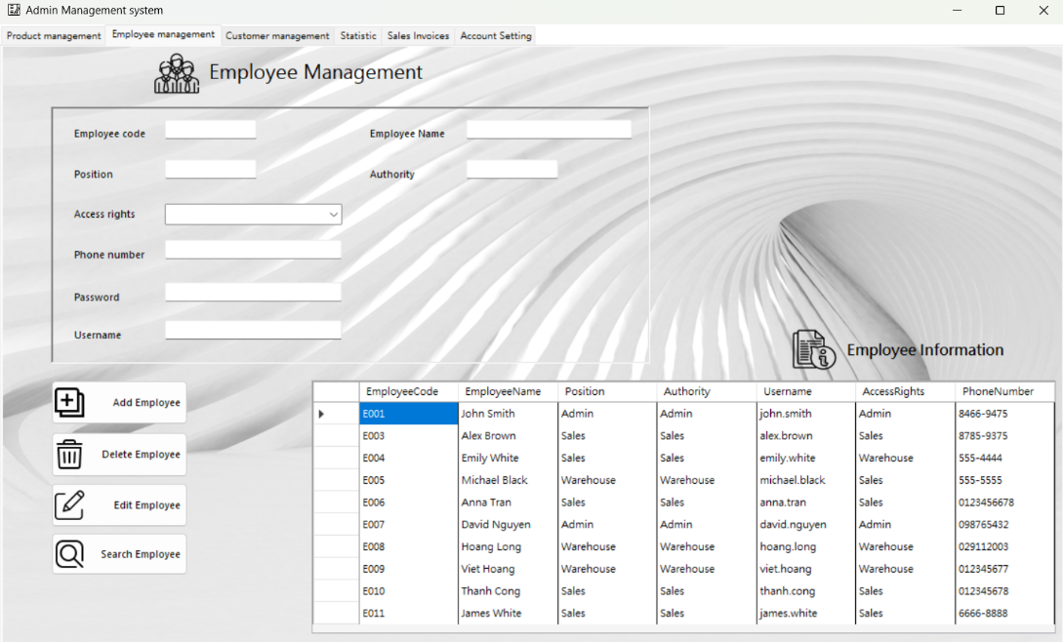

Figure 2-3: Employee management tab in Admin form

The “Employee Management” tab is an integral part of the Admin Management System. This tab provides administrators with a robust interface to manage employee information effectively and efficiently.

Functionalities:

* Employee Information Entry:
* Fields: The interface includes fields for entering or editing detailed employee information:
* Employee Code: A unique identifier for each employee.
* Employee Name: The full name of the employee.
* Position: The job title or role of the employee within the organization.
* Authority: The level of access or permissions assigned to the employee.
* Username: The username used by the employee for system login.
* Password: The password for the employee’s account, which should be securely hashed before storage.
* Phone Number: The contact number of the employee.
* Access Rights: The specific access rights or roles (e.g., Admin, Sales, Warehouse) assigned to the employee.
* Control Buttons:
* Add: Adds a new employee record to the database.
* Edit: Modifies the details of an existing employee.
* Delete: Removes an employee record from the database.
* Search: Searches for employees based on their names or other criteria.
* Data Display:
* Employee List: A DataGridView displays a list of employees with columns for Employee Code, Employee Name, Position, Authority, Username, Access Rights, and Phone Number.
* Sample Data: The table includes sample data for several employees, showcasing their respective details and providing a clear visualization of the employee database.

c) Customer management tab:

The “Customer Management” tab is a key component of the Admin Management System. This tab is designed to provide administrators with a comprehensive interface to manage customer information efficiently and effectively.

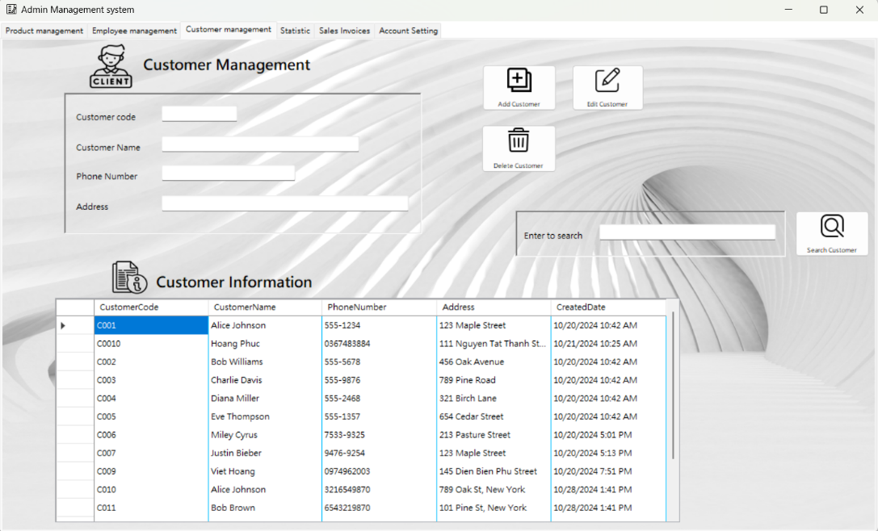

Figure 2-4: Customer management in Admin form

Functionalities:

* Customer Information Entry:
* Fields: The interface includes fields for entering or editing customer details:
* Customer Code: A unique identifier for each customer.
* Customer Name: The full name of the customer.
* Phone Number: The contact number of the customer.
* Address: The residential or business address of the customer.
* Control Buttons:
* Add: Adds a new customer record to the database.
* Edit: Modifies the details of an existing customer.
* Delete: Removes a customer record from the database.
* Search: Searches for customers based on their names or other criteria.
* Data Display:
* Customer List: A DataGridView displays a list of customers with columns for Customer Code, Customer Name, Phone Number, and Address.
* Sample Data: The table includes sample data for several customers, showcasing their respective details and providing a clear visualization of the customer database.

d) Statistics tab:

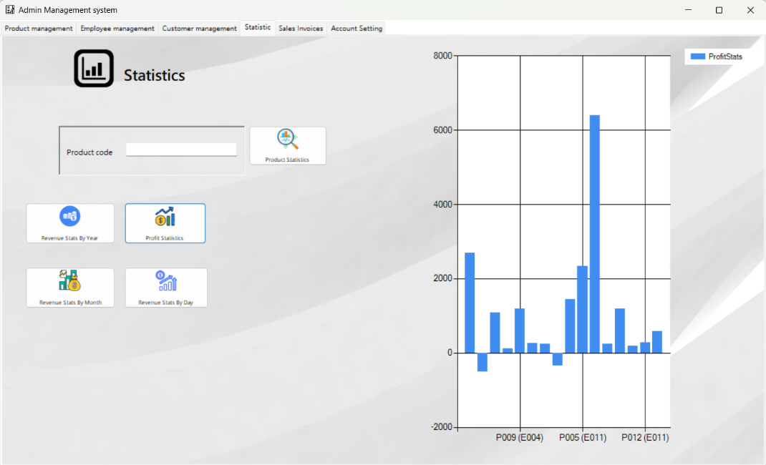

Figure 2-5: View statistics in Admin form

The "Statistics" tab is an essential feature of the Admin Management System. This tab provides administrators with a powerful interface to view and analyze various statistics related to products, sales, and profits.

Functionalities:

* Product Statistics:
* Fields: The interface includes a field for entering a product code to generate statistics specific to that product.
* Button: A "Product Statistics" button to generate and display product-specific statistics.
* Revenue Statistics:
* Buttons: The interface includes buttons for generating revenue statistics by different time frames:
* Revenue Stats By Year: Displays revenue statistics for a selected year.
* Revenue Stats By Day: Displays daily revenue statistics.
* Revenue Stats By Month: Displays monthly revenue statistics.
* Profit Statistics:
* Button: A "Profit Statistics" button to generate and display profit statistics across various products and employees.
* Data Display: A DataGridView at the bottom of the interface shows the profit statistics, including columns for Product Code, Employee Code, and Profit.
* Sample Data: The table includes sample data for products, employees, and their respective profits, providing a clear visualization of profit distribution.

e) Account setting tab:

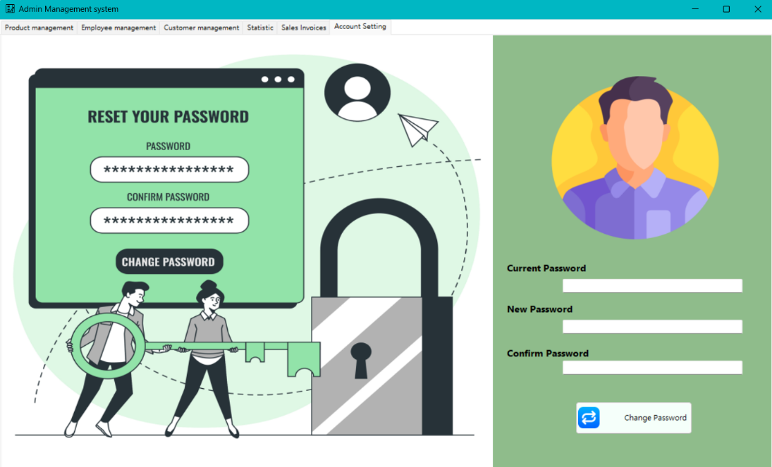

Figure 2-6: Account setting in Admin form

This tab provides administrators with a straightforward interface to change their account password, enhancing the security of the system.

Functionalities:

* Password Change:
* Fields: The interface includes fields for entering the current password and the new password:
* Current Password: A text field for entering the current password of the admin account.
* New Password: A text field for entering the new password.
* Confirm Password: A text field for re-entering the new password to confirm it.
* Control Button:
* Change Password: A button that, when clicked, updates the password for the admin account after validating the current password and ensuring the new password matches the confirmation.

f) Sales invoices tab:

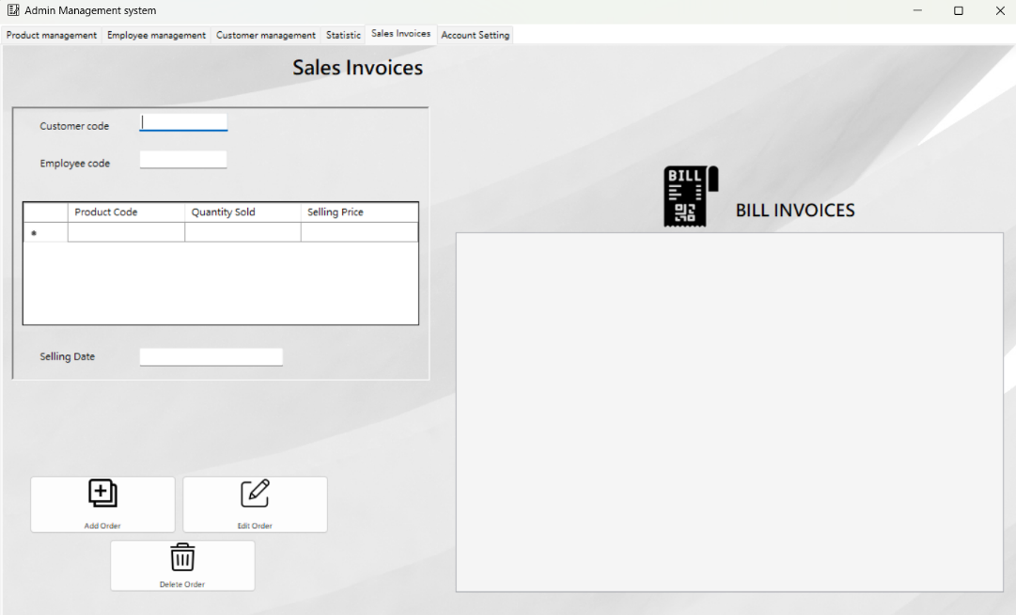

Figure 2-7: Sales invoices in Admin form

This tab provides administrators with a comprehensive interface to manage sales records, ensuring accurate and up-to-date sales data. It includes functionalities for adding, editing, and deleting sales entries, which are crucial for maintaining the integrity of sales data.

Functionalities:

* Sales Entry Management:
* Fields: The interface includes fields for entering the details of each sale:
* Customer Code: A text field for entering the code of the customer involved in the sale.
* Product Code: A text field for entering the code of the product sold.
* Quantity Sold: A text field for entering the number of units sold.
* Employee Code: A text field for entering the code of the employee who processed the sale.
* Selling Price: A text field for entering the price at which the product was sold.
* Selling Date: A text field for entering the date the sale was made.
* Control Buttons:
* Add Sale: A button that, when clicked, adds a new sale entry to the system, incorporating the details entered in the fields.
* Delete Sale: A button that, when clicked, deletes the selected sale entry from the system, ensuring the sales data is current and accurate.
* Edit Sale: A button that, when clicked, allows the administrator to modify the details of the selected sale entry.
* Sales Records Table:
* This table displays a list of sales entries, with columns for each critical piece of data:
* OrderID: The unique identifier for each sale.
* ProductCode: The code of the product sold.
* EmployeeCode: The code of the employee who made the sale.
* CustomerCode: The code of the customer involved in the sale.
* QuantitySold: The number of units sold.
* SaleDate: The date the sale was made.
* SellingPrice: The price at which the product was sold.
* CostPrice: The cost price of the product.

**2.1.1.3 Sales staff form:**

a) Product management tab:

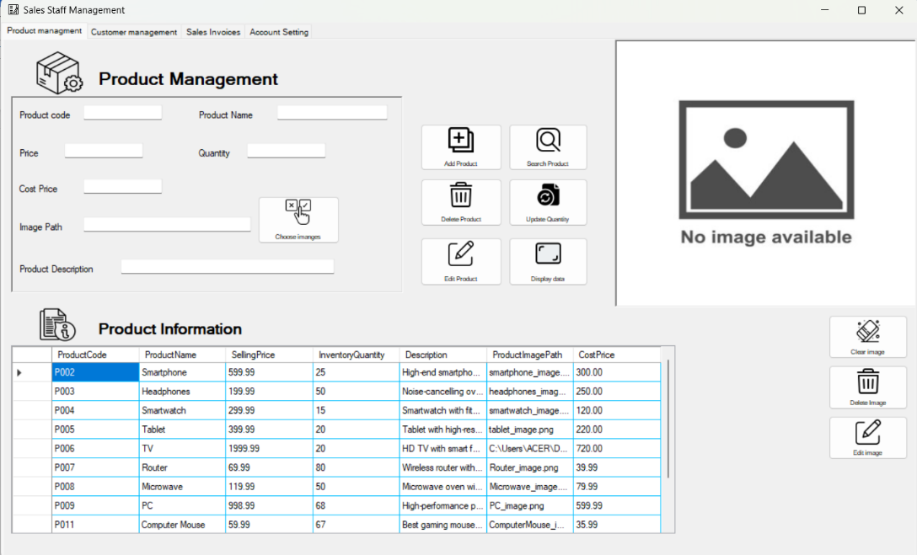

Figure 2-8: Sales staff form

Product management tab: Sales staff can effortlessly manage the entire product catalog. They can view detailed product information, including product code, name, price, inventory quantity, and descriptions. Functions include adding new products, editing existing products, deleting products, and searching for products based on various criteria.

b) Customer management tab:

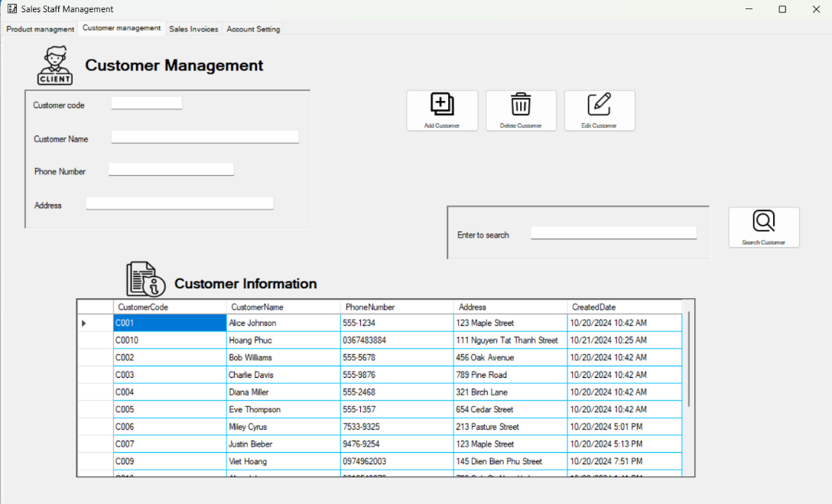

Figure 2-9: Customer management in Sales staff form

Customer management tab: This tab allows sales staff to maintain up-to-date customer records. They can add new customers, edit existing customer details, delete customer records, and search for customers by name or other attributes. The tab also displays a list of customers with relevant details such as customer code, name, phone number, and address.

c) Sales invoices tab:

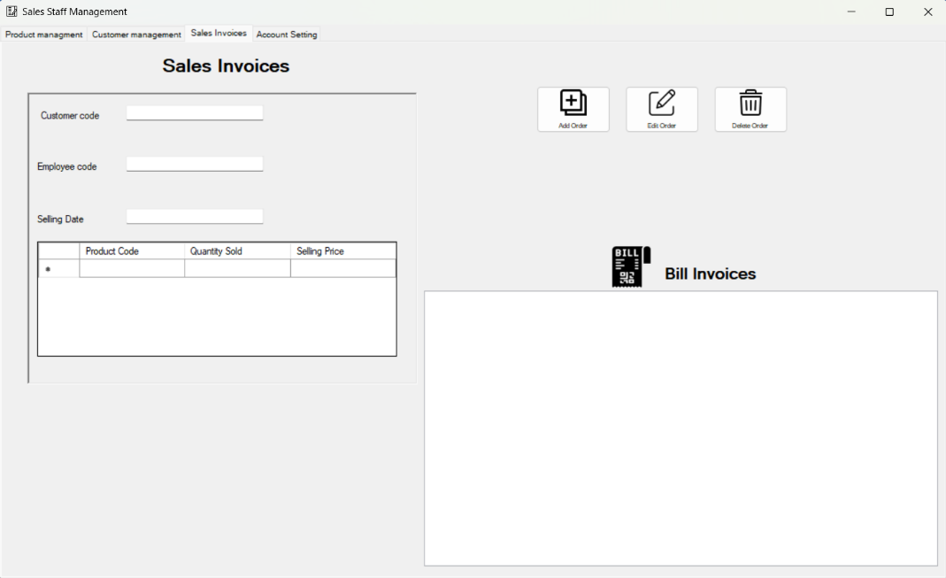

Figure 2-10: Sales invoices tab in Sales staff form

Sales Invoice Tab: Sales staff can manage sales transactions efficiently. They can create new sales invoices, edit existing ones, and delete invoices. The tab provides fields for entering product code, employee code, customer code, quantity sold, sale date, and selling price, ensuring accurate and streamlined sales management.

d) Account setting tab:

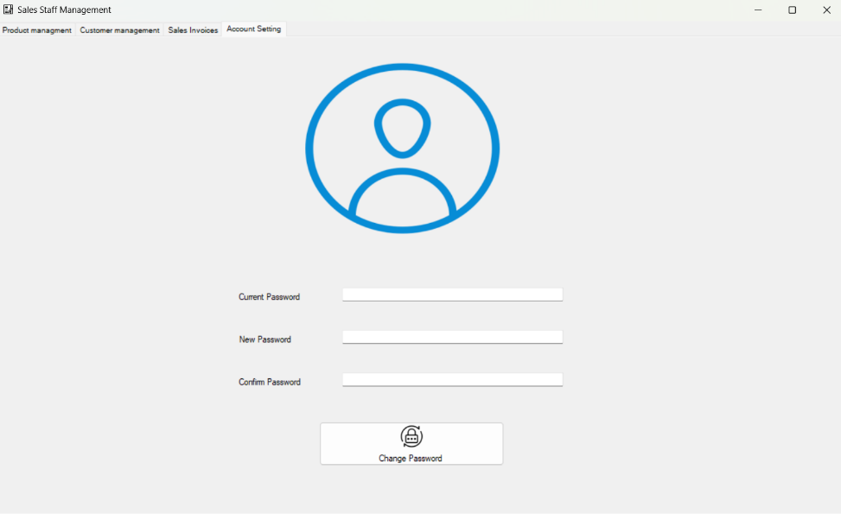

Figure 2-11: Account setting tab in Sales staff form

Account Settings Tab: This tab provides a secure interface for sales staff to change their account passwords. They can enter their current password, specify a new password, and confirm it. The system validates the current password and ensures the new password matches the confirmation, enhancing account security.

**2.1.1.4 Warehouse staff form:**

a) Product management tab:

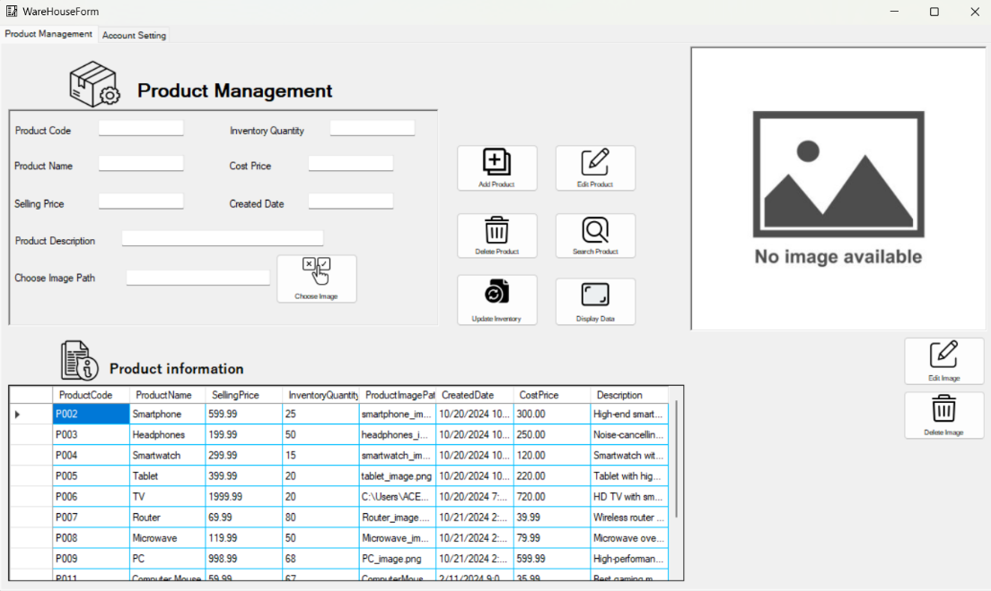

Figure 2-12: Product management tab in Warehouse form

Product Management Tab: This tab equips warehouse staff with the tools needed to manage the entire product inventory. They can view detailed product information, including product code, name, price, inventory quantity, descriptions, and images. Functions include adding new products to the inventory, editing existing product details, updating inventory quantities, and deleting products. Additionally, staff can search for products using various criteria such as product code, name, and price, ensuring efficient and accurate inventory tracking.

b) Account setting tab:

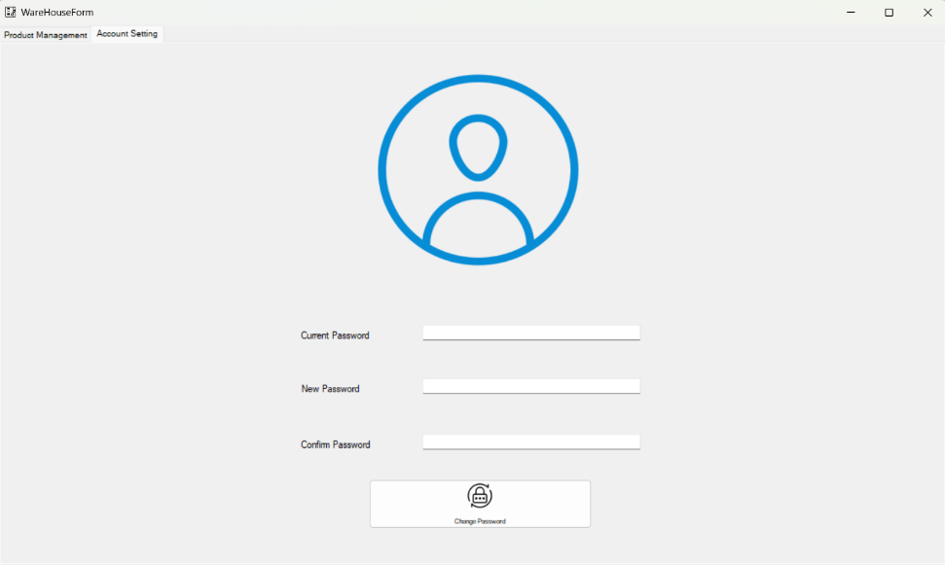

Fgiure 2-13: Account setting tab in Warehouse form

Account Settings Tab: This tab provides a secure interface for warehouse staff to update their account passwords. They can enter their current password, specify a new password, and confirm the new password. The system validates the current password and ensures the new password matches the confirmation, enhancing the security of their account and protecting sensitive inventory data.

**2.1.2 Design outputs (reports, visualizations) to present data to users in a meaningful way.**

**2.1.2.1 Product management tab:**

* Purpose: To provide users with a comprehensive tool for managing product data, essential for inventory management and sales tracking.
* Key Features:
* Product Code and Name: Allows users to input and manage unique product codes and names.
* Price and Cost Price: Fields for entering and displaying the selling and cost prices.
* Image Path: Lets users upload and manage images associated with each product.
* Product Description: Provides a space for detailed product descriptions.
* Quantity: Tracks available quantities of each product.

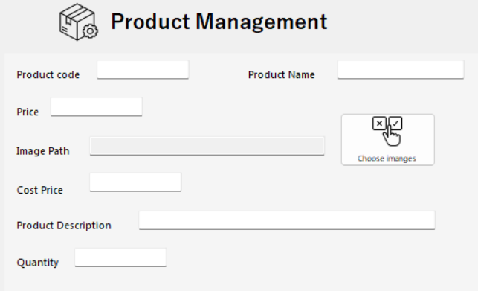

Figure 2-14: Key Features in product management tab

* Outputs and Visualizations:
* Data Grid View:
* Visualization: A table that displays product details, including Product Code, Name, Price, Cost Price, Quantity, and Description.

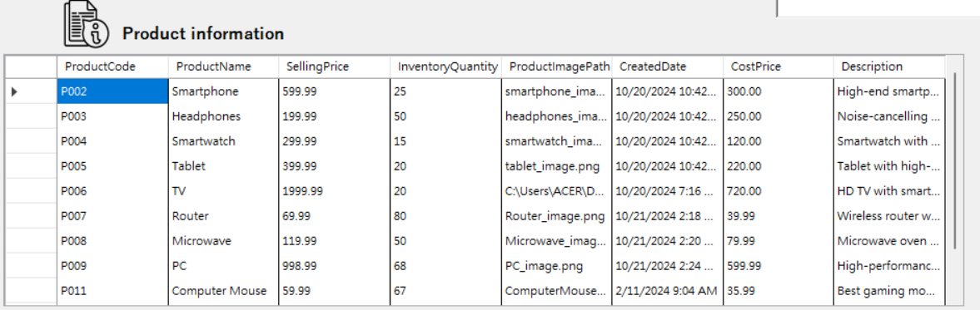

Figure 2-15: Data Grid View

* Purpose: Provides a clear and structured view of all product information for easy management and updates.
* Interactive Form Controls:
* Buttons like Add Product, Edit Product, Update Quantity, Delete Product:

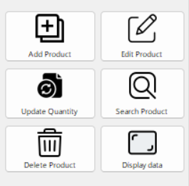

Figure 2-16: Buttons like Add Product, Edit Product, Update Quantity, Delete Product

* Purpose: These interactive elements allow users to perform CRUD (Create, Read, Update, Delete) operations efficiently.
* Data Output: Real-time updates to the data grid view as users add, edit, or delete products.
* Search Functionality:
* Visualization: A search bar to filter and find specific products.
* Purpose: Helps users quickly locate products based on specified criteria.

I want to search “Switch” product in the inventory:

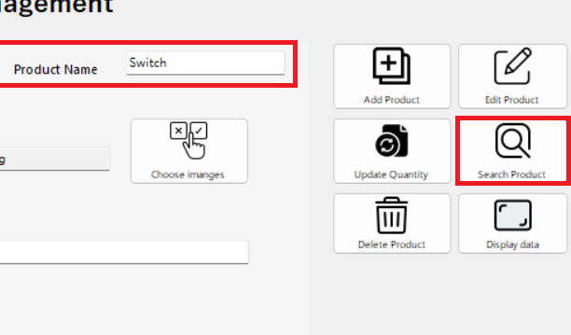

Figure 2-17: Search Functionality

After I press the “Search” button, it will appear its image and information in the table:

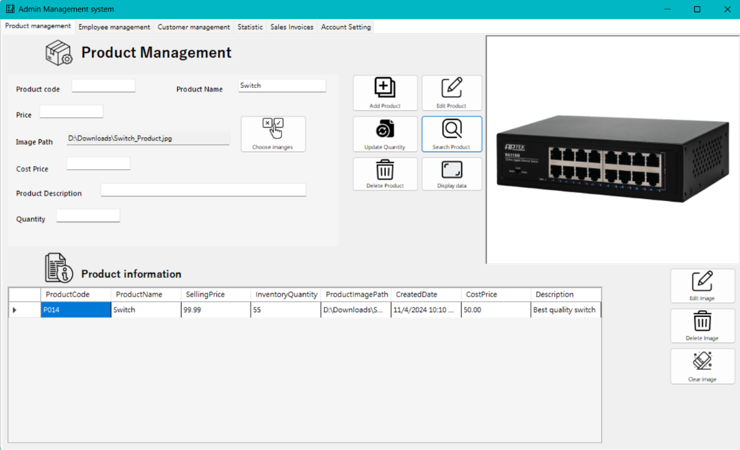

Figure 2-18: Layout

* Example Output in the Application:

When users interact with the Product Management tab:

* Adding a Product: Users input data into fields (Product Code, Name, Price, etc.) and click 'Add Product.' The new product appears immediately in the data grid.

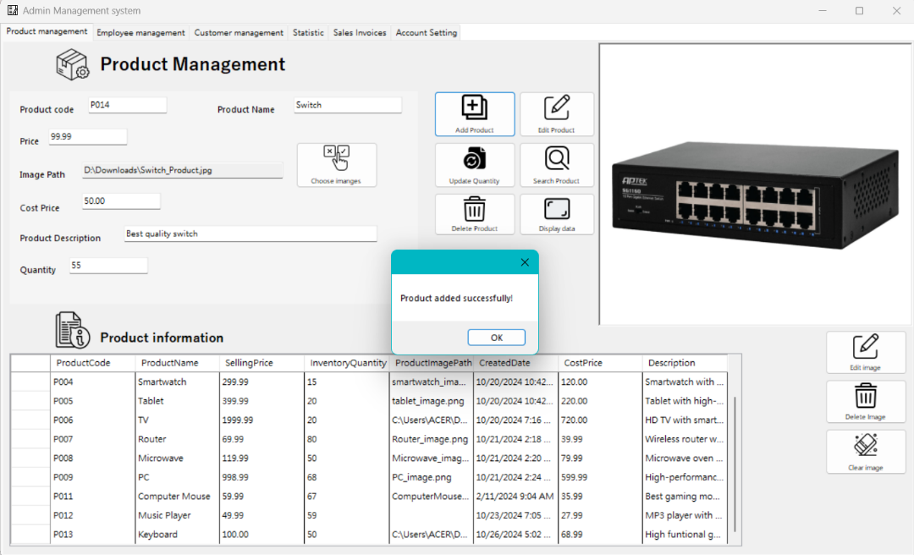

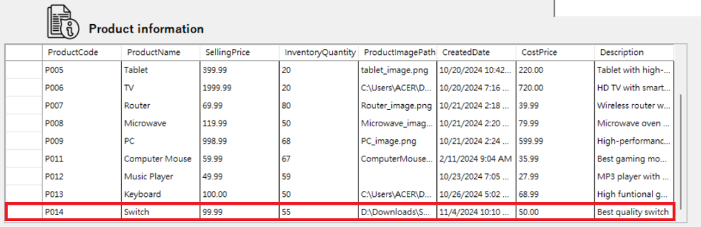

Figure 2-19: Adding a product

* Editing a Product: Users select a product from the grid, update its details using form fields, and click 'Edit Product.' Changes reflect instantly in the grid.

I want to edit product’s information: change price from 99.99 to 89.99, cost price from 50.00 to 49.99, product’s description:

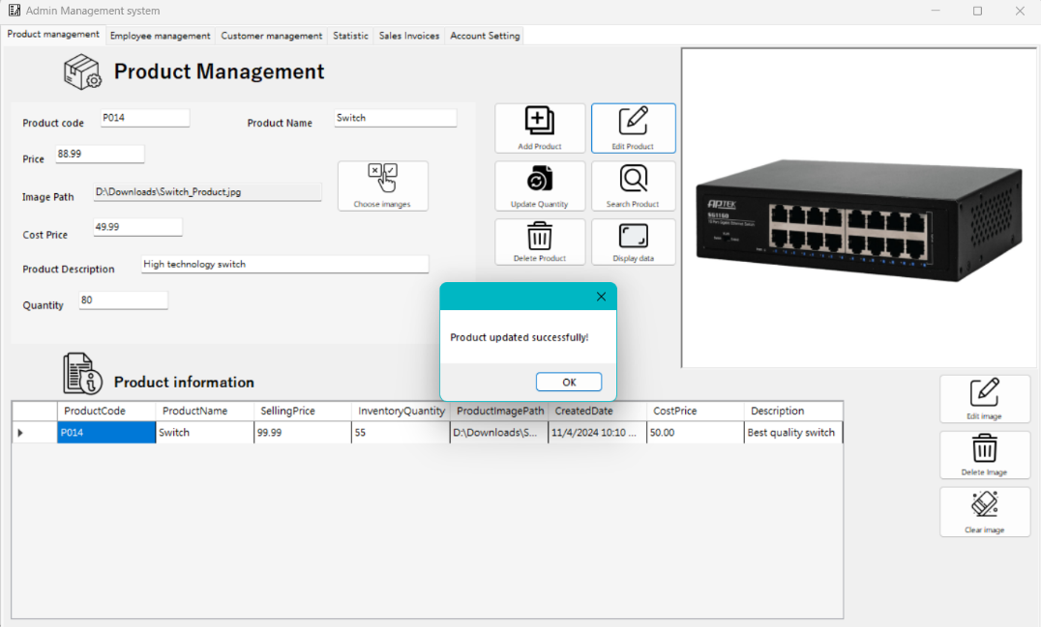

The product’s information has changed in the table:

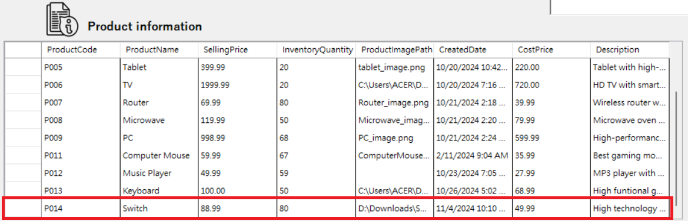

Figure 2-20: Edit a product

* Updating Quantity: Users can adjust stock levels via the 'Update Quantity' button, with updates appearing in the grid view.

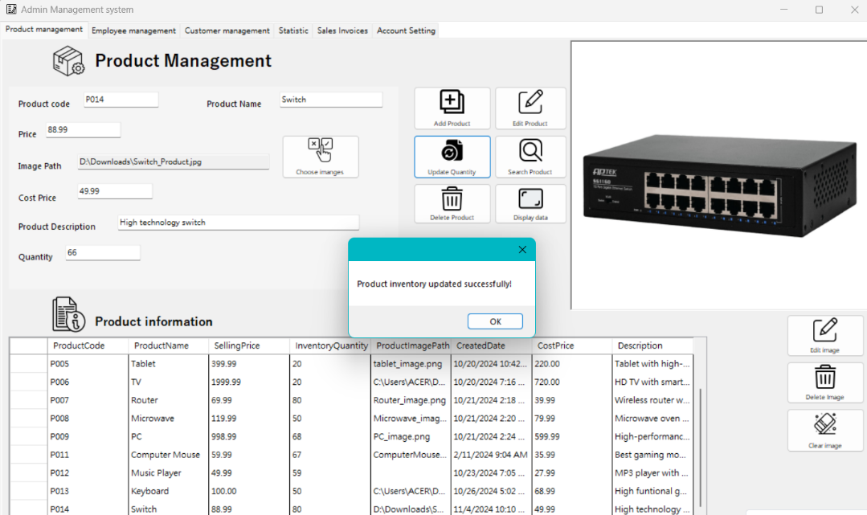

Produt’s quantity change from 80 to 66:



Figure 2-21: Update quantity

* Deleting a Product: Selecting and removing a product updates the data grid to reflect the change.

I enter product code and press button “ Delete Product”:

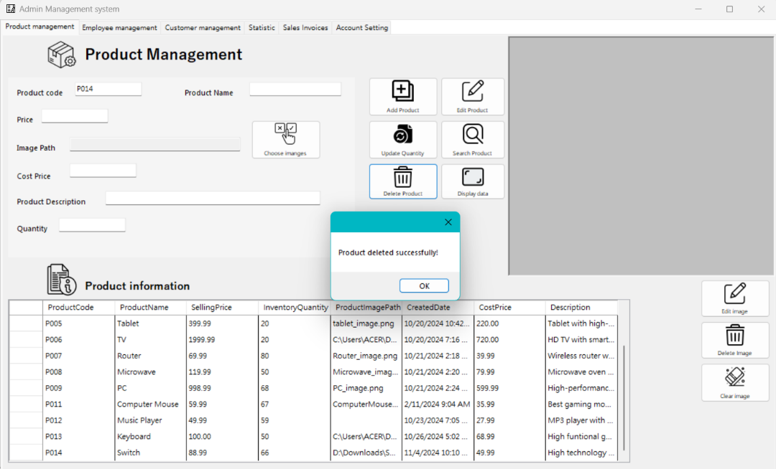

It will dissapear in table: There’s no switch product in the table

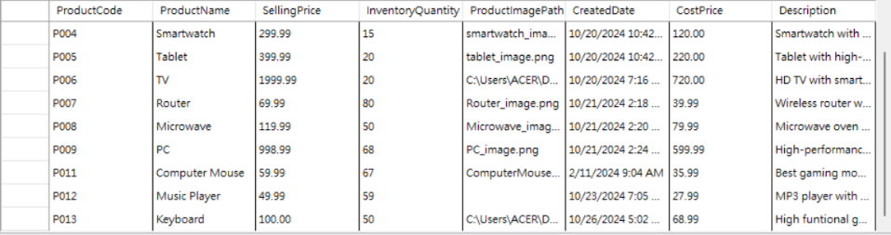

Figure 2-22: Delete product

🡺 The Product Management tab effectively presents data through a combination of data grid views, interactive form controls, and search functionality. These features enable users to manage product information efficiently, ensuring that the system supports accurate inventory management and sales tracking.

**2.1.2.2 Employee management tab:**

* Purpose: To provide administrators with a comprehensive tool for managing employee records, which is essential for tracking employee details, assigning roles, and ensuring proper access control within the system.
* Key Features:
* Employee Data Entry and Display:
* Employee Code and Name: Fields for entering unique employee codes and names ensure each employee is identifiable.
* Position and Authority: Allows users to specify the position and authority level of each employee, helping define roles within the organization.
* Access Rights: Enables administrators to manage access rights, ensuring employees have appropriate permissions.
* Phone Number: Tracks contact information for each employee.
* Username and Password: Provides fields for creating login credentials, facilitating secure access to the system.

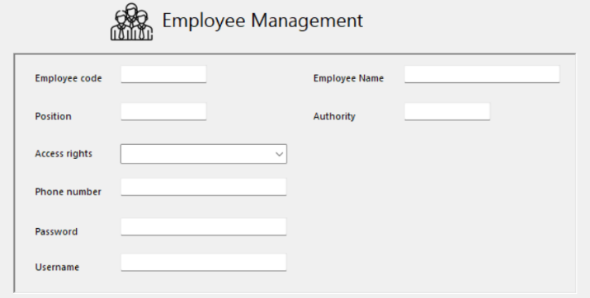

Figure 2-23: Employee Data Entry and Display

* Interactive Buttons:

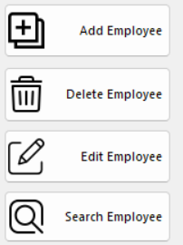

Figure 2-24: Interactive Buttons

* Add Employee: Facilitates the addition of new employee records.
* Edit Employee: Enables users to update existing employee details.
* Delete Employee: Allows the removal of employee records that are no longer needed.
* Search Employee: Provides a quick search function to find specific employees.
* Outputs and Visualizations:
* Data Grid View: Employee Information
* Visualization: A table that displays employee details, including Employee Code, Name, Position, Authority, Username, Access Rights, and Phone Number.

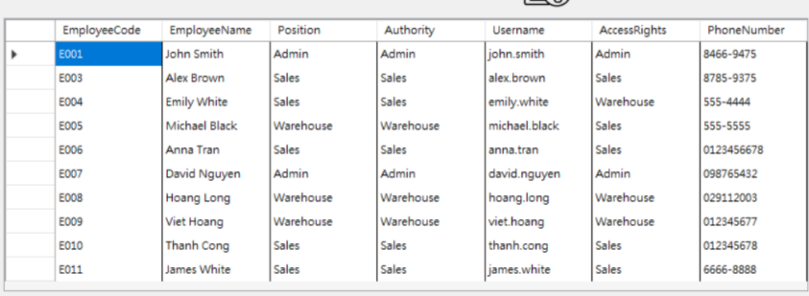

Figure 2-25: Employee Information

* Purpose: Provides a clear and structured view of all employee information for easy management and updates.
* Example Output in the Application:

When users interact with the Employee Management tab:

* Adding an Employee: Users input data into fields (Employee Code, Name, Position, etc.) and click 'Add Employee.' The new employee appears immediately in the data grid.

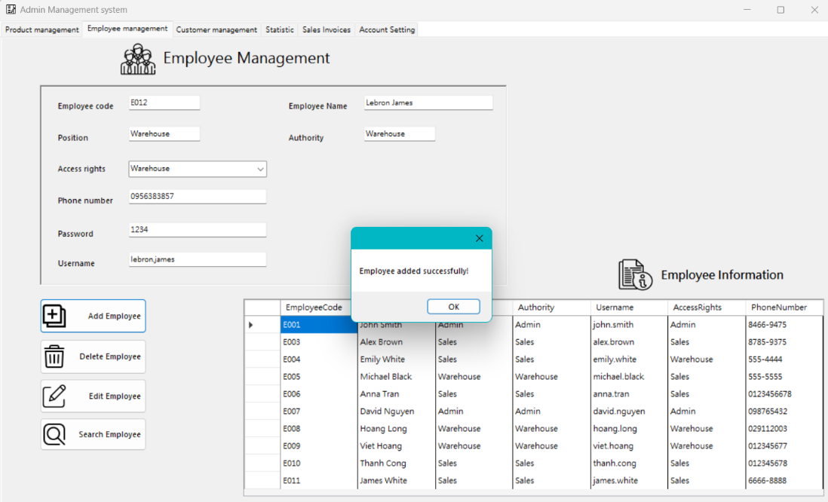

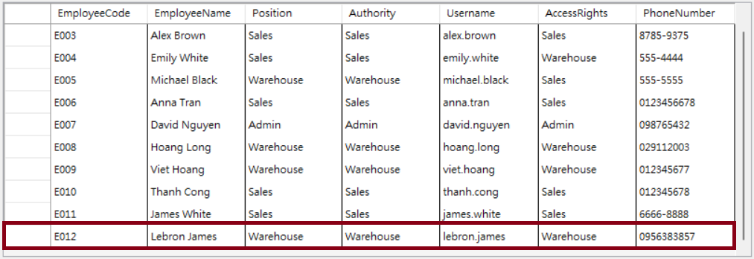

Figure 2-26: Example Output in the Application

* Editing an Employee: Users select an employee from the grid, update their details using form fields, and click 'Edit Employee.' Changes reflect instantly in the grid.

I want to edit employee’s position from Warehouse to Sales:

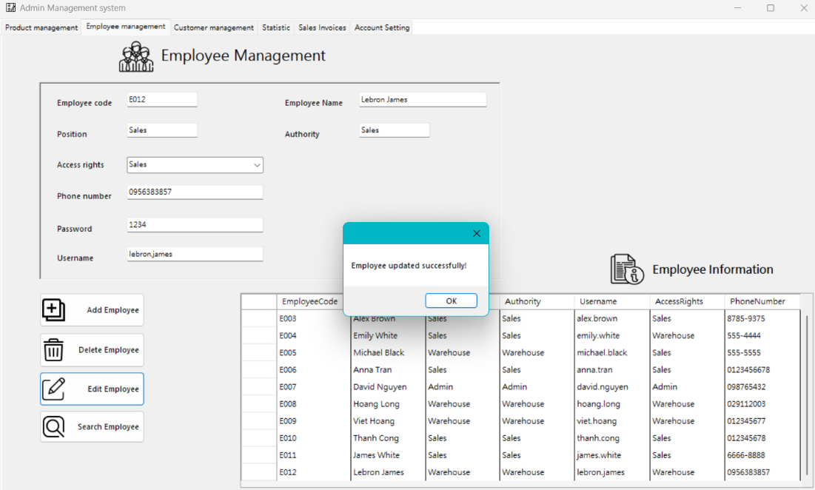

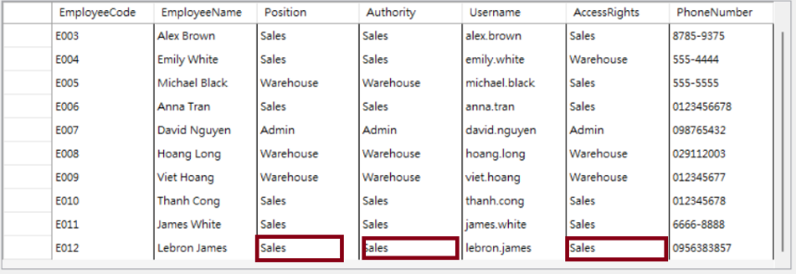

Figure 2-27: Editing an Employee

* Deleting an Employee: Selecting and removing an employee updates the data grid to reflect the change.

User selecting employee to delete by enter their code:

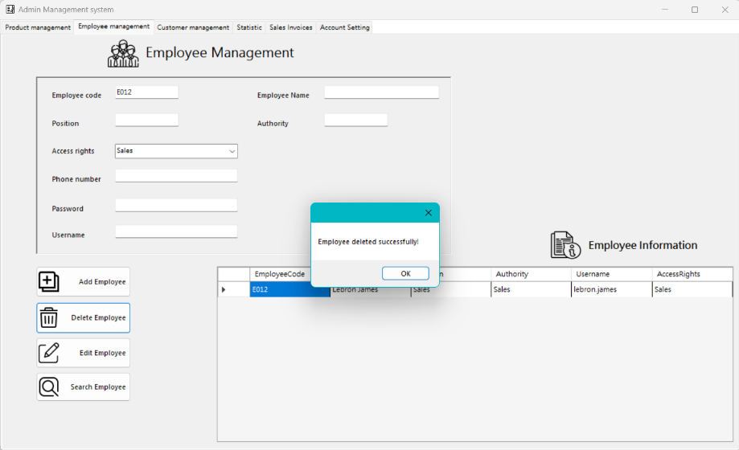

And then employee’s information will appear in the table: There’s no “Lebron James” information in the table:

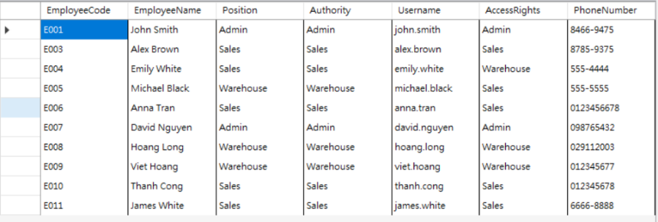

Figure 2-28: Deleting an Employee

* Searching for an Employee: The search bar allows users to quickly locate specific employees based on the entered criteria.

First user enter employee’s name, after that enter “Search employee” button. Employee’s information will appear in the table:

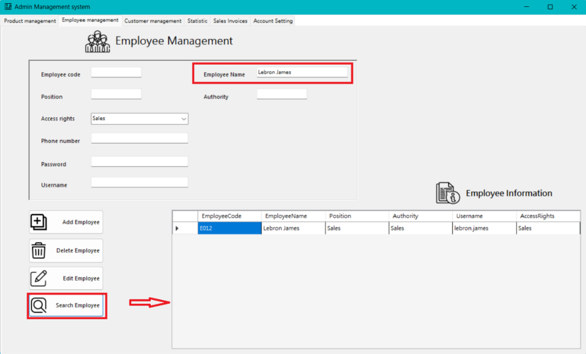

Figure 2-29: Searching for an Employee

🡺 The Employee Management tab effectively presents data through a combination of data grid views, interactive form controls, and search functionality. These features enable users to manage employee information efficiently, ensuring that the system supports accurate record-keeping and effective administrative management.

**2.1.2.3 Customer management tab:**

* Purpose: To provide a comprehensive tool for managing customer details, which is essential for tracking customer interactions, maintaining accurate records, and facilitating personalized customer service.
* Key Features and Visualizations:
* Customer Data Entry and Display:
* Customer Code and Name: Fields for entering unique customer codes and names ensure each customer is identifiable.
* Phone Number: Tracks contact information for each customer.
* Address: Allows users to input and manage customer addresses, providing geographical context.
* Created Date: Automatically records the date when a customer record is created.

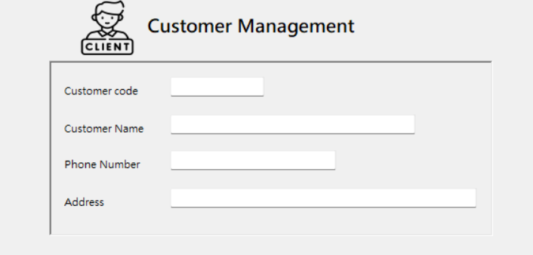

Figure 2-30: Customer Data Entry and Display

* Interactive Buttons:
* Add Customer: Facilitates the addition of new customer records.
* Edit Customer: Enables users to update existing customer details.
* Delete Customer: Allows the removal of customer records that are no longer needed.
* Search Customer: Provides a quick search function to find specific customers.
* Display Customer Information: Shows a detailed view of the customer information entered.

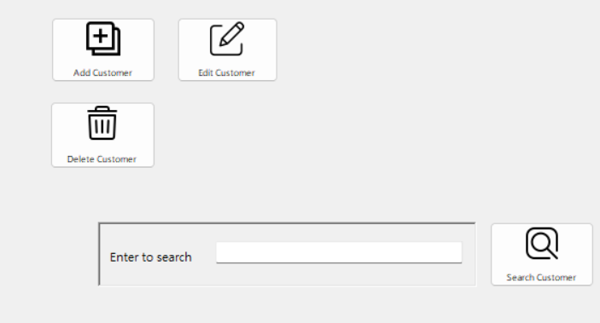

Figure 2-31: Interactive Buttons

* Outputs and Visualizations:
* Data Grid View: Customer Information
* Visualization: A table that displays customer details, including Customer Code, Customer Name, Phone Number, Address, and Created Date.
* Purpose: Provides a clear and structured view of all customer information for easy management and updates.

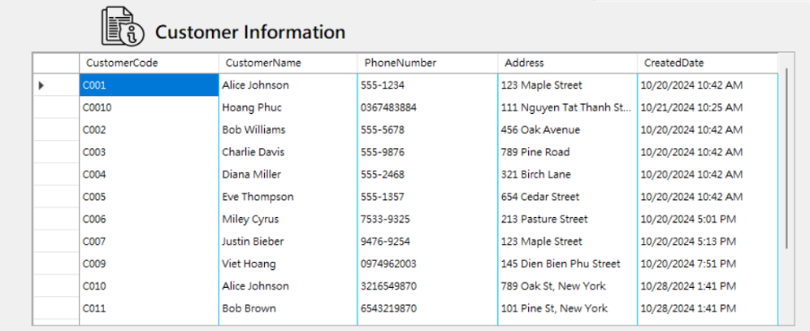

Figure 2-32: Outputs and Visualizations

* Example Output in the Application:

When users interact with the Customer Management tab:

* Adding a Customer: Users input data into fields (Customer Code, Name, Phone Number, Address) and click 'Add Customer.' The new customer appears immediately in the data grid.

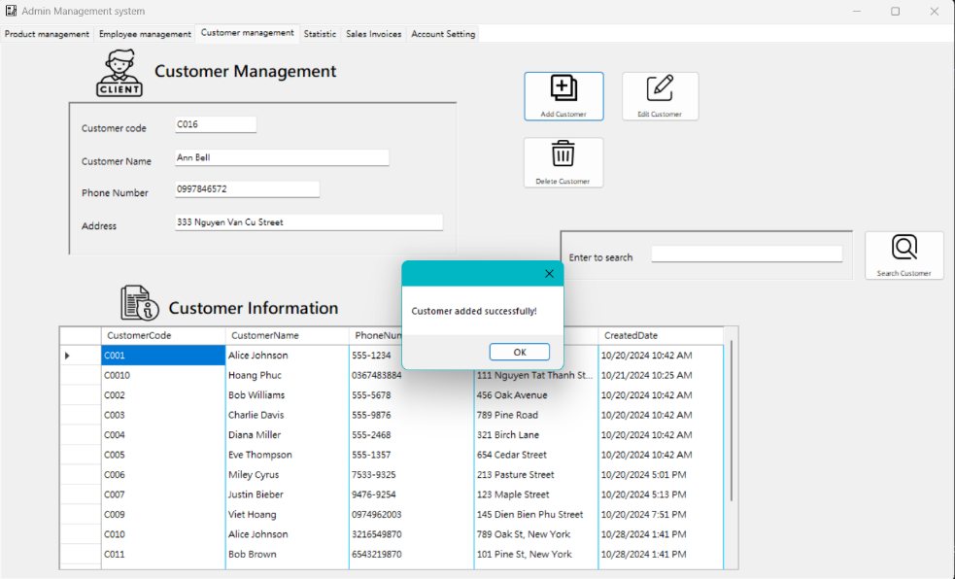

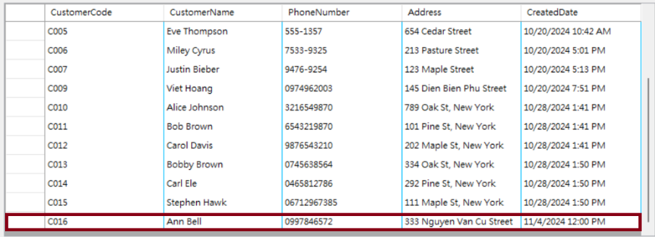

Figure 2-33: Example Output in the Application

* Editing a Customer: Users select a customer from the grid, update their details using form fields, and click 'Edit Customer.' Changes reflect instantly in the grid.

I want to change customer’s address from 333 Nguyen Van Cu Street to 123 Le Viet Thuat Street:

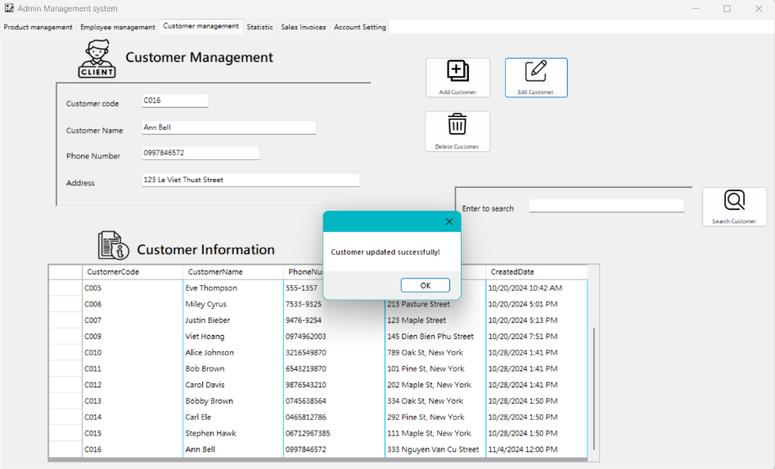

Customer’s address changed in the grid:



Figure 2-34: Editing a Customer

* Deleting a Customer: Selecting and removing a customer updates the data grid to reflect the change.

I want to delete customer “C016” name “Ann Bell”. First I enter customer code and click delete button

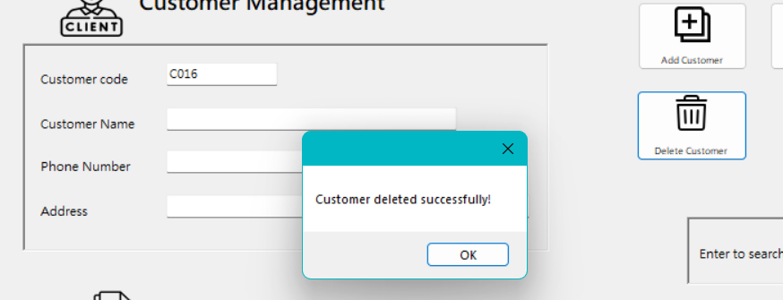

Figure 2-35: Deleting a Customer

* Searching for a Customer: The search bar allows users to quickly locate specific customers based on the entered criteria.

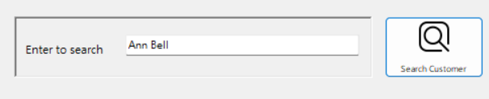

Customer’s information will appear in the grid:

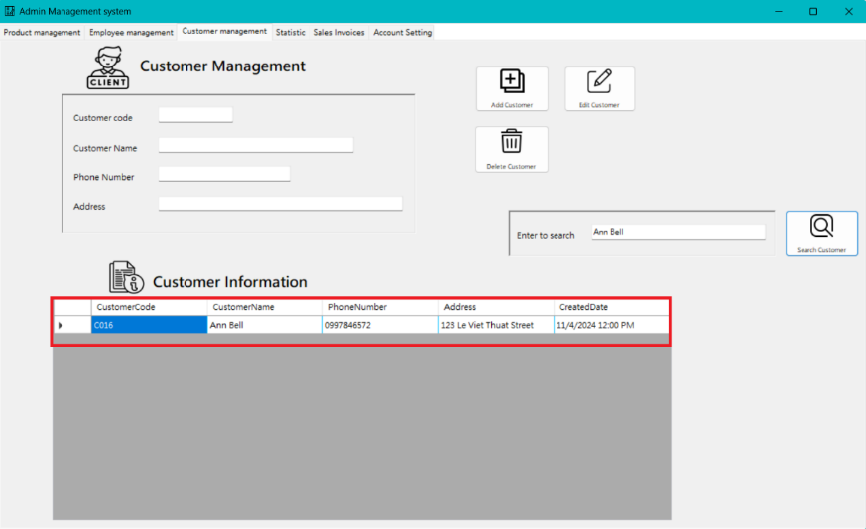

Figure 2-36: Searching for a Customer

🡺 The Customer Management tab effectively presents data through a combination of data grid views, interactive form controls, and search functionality. These features enable users to manage customer information efficiently, ensuring that the system supports accurate record-keeping and effective customer relationship management.

**2.1.2.4 Statistics tab:**

* Purpose: To offer a comprehensive view of key performance indicators (KPIs) through interactive and visual data representations. This helps users understand trends, monitor performance, and make informed decisions.
* Key Features and Visualizations:
* Product Statistics:
* Product Code Input: Allows users to enter a specific product code to fetch statistics related to that product.
* Product Statistics Button: Generates detailed statistics for the entered product code.

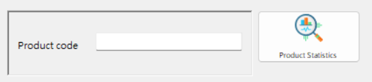

Figure 2-37: Product Code Input

* Revenue Statistics:
* Revenue Stats By Year Button: Displays annual revenue statistics.
* Revenue Stats By Month Button: Shows monthly revenue statistics.
* Revenue Stats By Day Button: Provides daily revenue statistics.
* Profit Statistics:
* Profit Statistics Button: Generates detailed profit statistics.

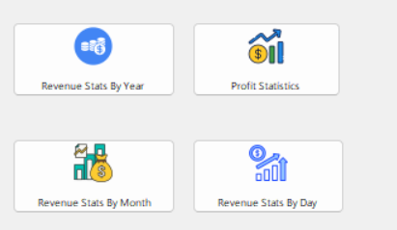

Figure 2-38: Profit Statistics Button

* Outputs and Visualizations:
* Graph: Revenue by Year
* Visualization: A line graph displaying revenue statistics over a range of years
* Purpose: Helps users visualize and understand annual revenue trends, making it easy to identify growth patterns or declines.

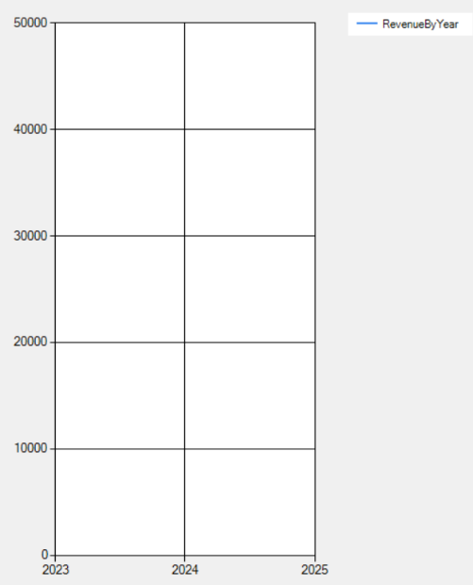

Figure 2-39: Graph: Revenue by Year

* Example Output in the Application:

When users interact with the Statistics tab:

* Product Statistics: Users enter a product code and click 'Product Statistics.' The system generates detailed statistics related to sales, revenue, and profit for that specific product.

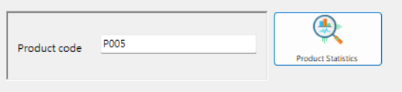

Product statistic of product “P005”:

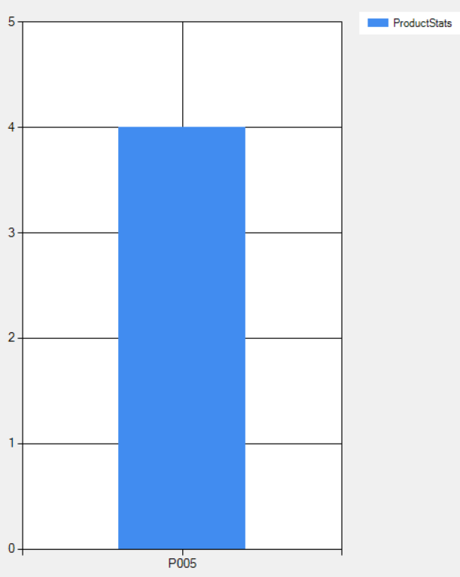

Figure 2-40: Example Output in the Application

* Revenue Stats By Year: Clicking 'Revenue Stats By Year' updates the graph to display annual revenue, providing a visual representation of revenue performance over multiple years.

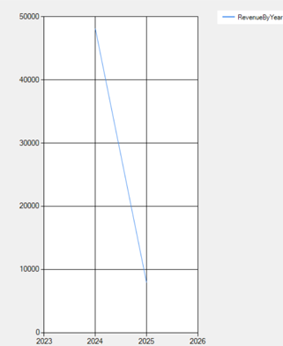

Figure 2-41: Revenue Stats By Year

* Revenue Stats By Month: Users click 'Revenue Stats By Month' to see a monthly breakdown of revenue, helping them understand seasonal trends and monthly performance variations.

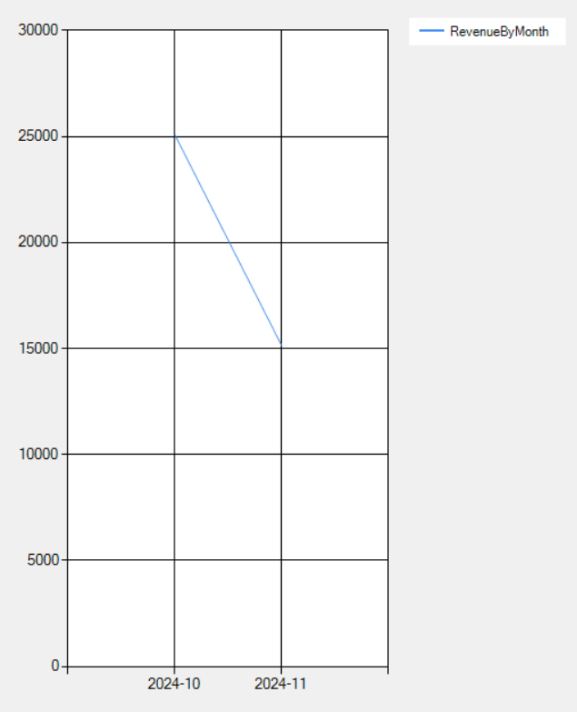

Figure 2-42: Revenue Stats By Month

* Revenue Stats By Day: Clicking 'Revenue Stats By Day' shows daily revenue statistics, offering a granular view of daily sales performance.

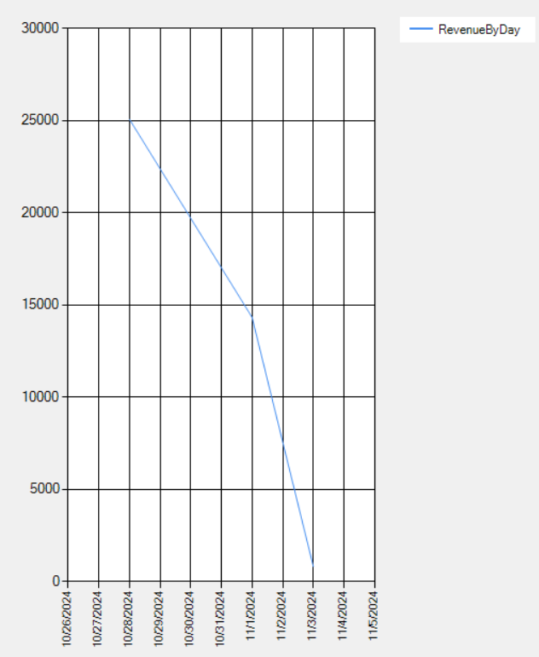

Figure 2-43: Revenue Stats By Day

* Profit Statistics: Clicking 'Profit Statistics' generates a detailed report on profits, including gross and net profit margins.

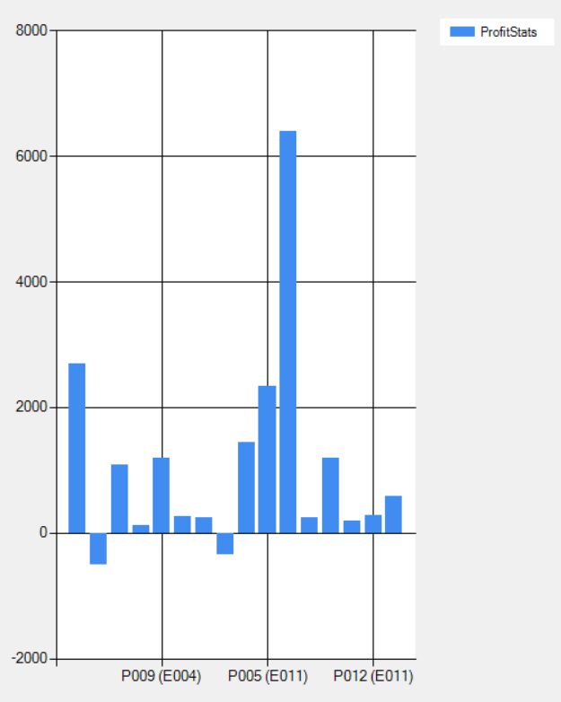

Figure 2-44: Profit Statistics

🡺 The Statistics tab effectively presents data through a combination of input fields, buttons, and dynamic graphs. These features enable users to generate detailed and specific statistical reports, ensuring that the system supports accurate performance monitoring and data-driven decision-making.

**2.1.2.5 Sales invoice tab:**

* Purpose: To provide a comprehensive tool for managing sales invoices, essential for tracking transactions, generating accurate invoices, and maintaining updated sales records.
* Key Features and Visualizations:
* Sales Data Entry:
* Customer Code and Employee Code: Fields for entering unique customer and employee codes ensure each transaction is linked to the correct parties.
* Product Code: Allows users to specify the products involved in each sale.
* Quantity Sold and Selling Price: Tracks the quantity of products sold and their respective selling prices, crucial for calculating total sales amounts.
* Selling Date: Records the date of each transaction, providing chronological context.
* Data Grid View for Entering Orders: Users can input multiple products and quantities for a single order in a grid format before saving the entire order.

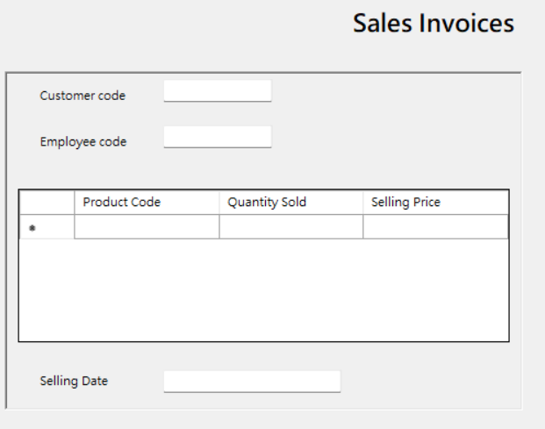

Figure 2-45: Sales Data Entry

* Outputs and Visualizations:
* Data Grid View: Enter Order
* Visualization: A data grid where users enter details of the order, including Product Code, Quantity Sold, and Selling Price.
* Purpose: Allows users to input multiple products in a structured manner for a single order, ensuring all necessary details are captured efficiently.

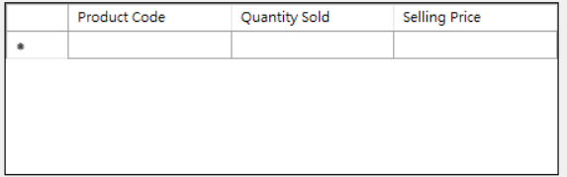

Figure 2-46: Data Grid View: Enter Order

* Table Display: Bill Invoices
* Visualization: A table under the "Bill Invoices" section that displays all recorded orders. This includes Customer Code, Employee Code, Product Code, Quantity Sold, Selling Price, Total Amount, and Selling Date.
* Purpose: Provides a clear overview of all orders entered into the system, making it easy for users to review, manage, and validate sales transactions.

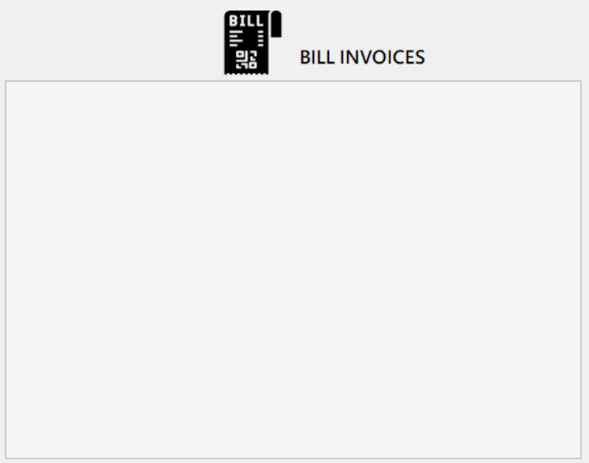

Figure 2-47: Table Display: Bill Invoices

* Example Output in the Application:

When users interact with the Sales Invoices tab:

* Entering an Order: Users input data into the data grid (Product Code, Quantity Sold, Selling Price) and click 'Add Order.' The new transaction appears immediately in the "Bill Invoices" table, providing real-time updates.

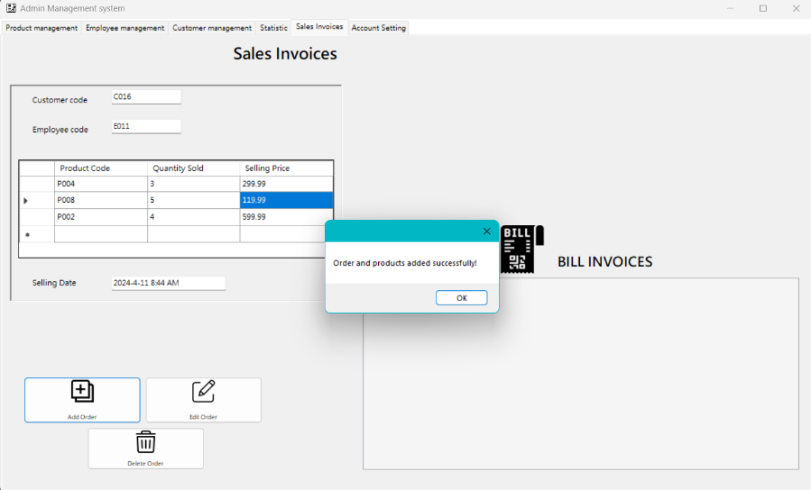

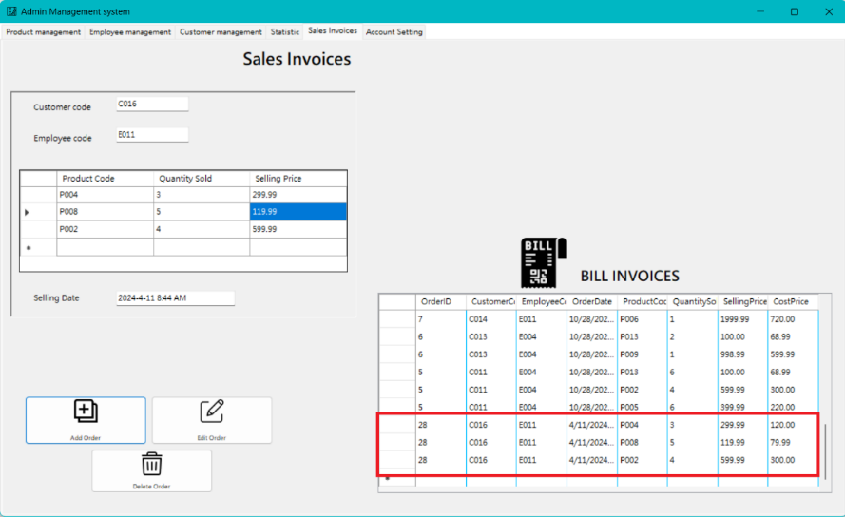

Figure 2-48: Entering an Order

* Editing an Order: Users select an order from the "Bill Invoices" table, update its details using the data grid fields, and click 'Edit Order.' Changes reflect instantly in the table.

Assuming that customer doesn’t want to buy 3 products anymore. And he give back 2 products and just buy 1 product:

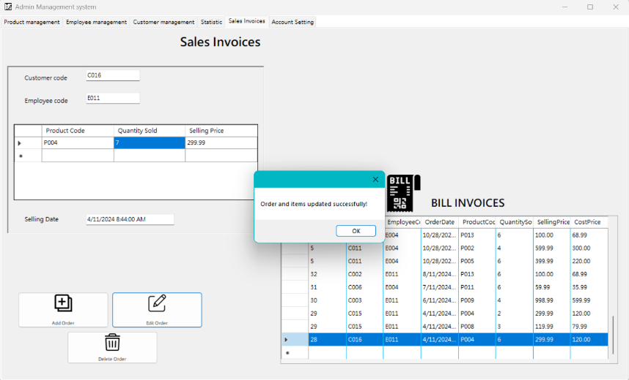

So as you can see, there is just 1 order from customer “C016”:

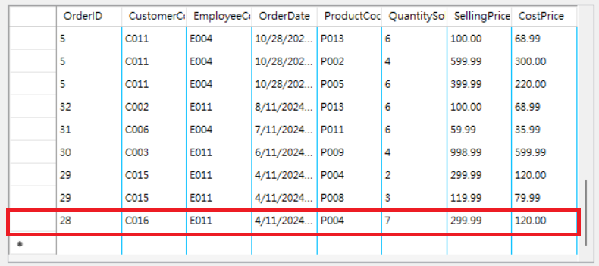

Figure 2-49: Editing an Order

* Deleting an Order: Selecting and removing an order from the "Bill Invoices" table updates the table to reflect the change.

I want to delete customer “C016” ’s order:

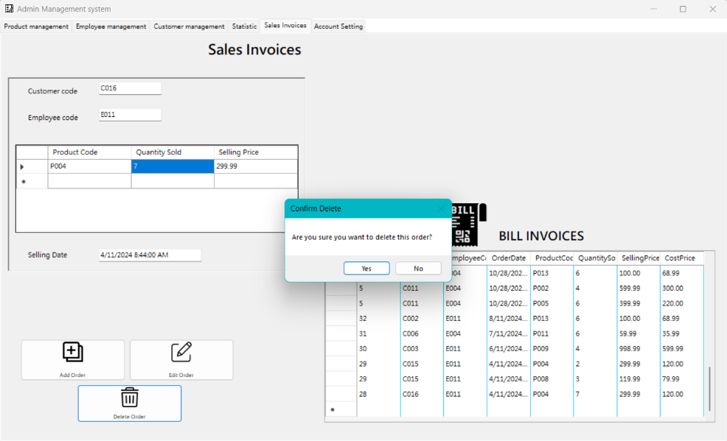

And you can see thers is no order from customer”C016”:

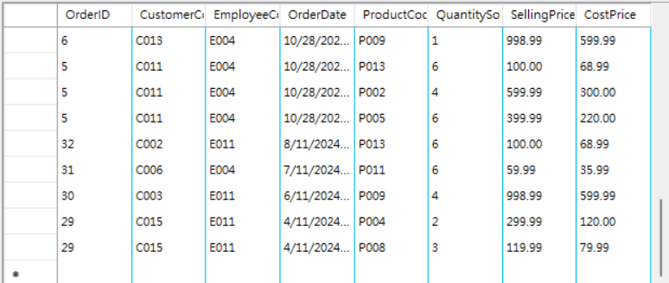

Figure 2-50: Deleting an Order

🡺 The Sales Invoices tab effectively presents data through a combination of data grid views for order entry and a comprehensive table under the "Bill Invoices" section. These features enable users to manage sales transactions efficiently, ensuring that the system supports accurate record-keeping and effective transaction management.

**2.1.2.6 Account setting tab:**

* Purpose: To provide users with a secure and user-friendly interface for managing their account settings, particularly focusing on password management to ensure account security.
* Key Features and Visualizations:
* Password Management:
* Current Password: Field for entering the user's current password to verify their identity.
* New Password: Field for entering a new password.
* Confirm Password: Field for re-entering the new password to ensure accuracy.
* Interactive Button:
* Change Password: Button that allows users to update their password securely after entering the required information.
* Outputs and Visualizations:
* Password Change Form:
* Visualization: A simple and clear form layout with fields for Current Password, New Password, and Confirm Password.
* Purpose: Ensures that users can easily understand and complete the process of changing their password, thereby maintaining account security.

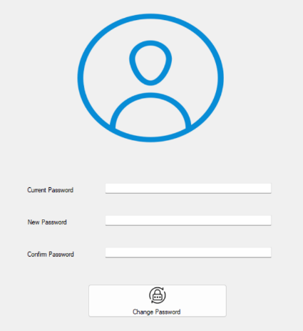

Figure 2-51: Password Change Form

* Example Output in the Application:

When users interact with the Account Setting tab:

* Changing Password: Users enter their current password, new password, and confirm the new password. Upon clicking the 'Change Password' button, the system verifies the information and updates the password if all criteria are met.

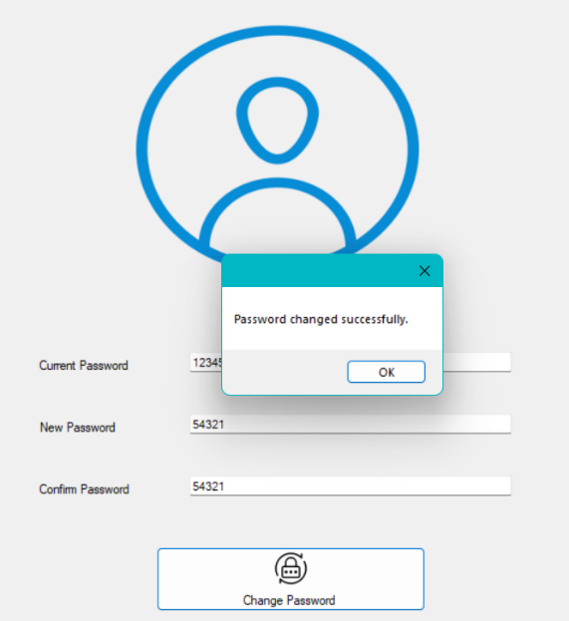

Figure 2-52: Changing Password

* Error Handling: If the passwords do not match or if the current password is incorrect, the system prompts the user to correct the information, ensuring a secure and accurate password change process.

If user enter wrong current password:

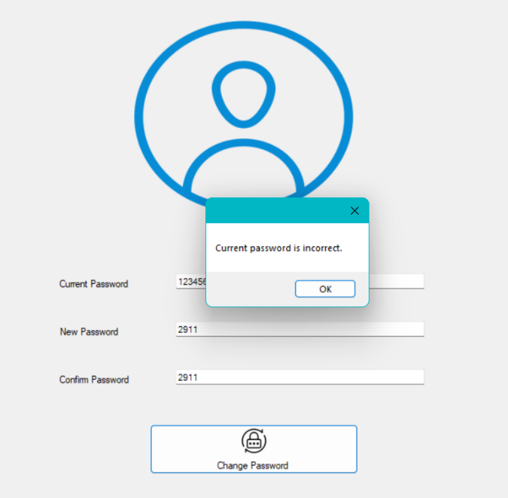

**2.1.3 Implement data validation rules to ensure data accuracy and consistency during input**

Data Validation Rules are specific criteria or constraints applied to data to ensure its accuracy, consistency, and integrity before it is processed or stored. These rules can include checks for data type, range, format, uniqueness, and referential integrity. By enforcing these rules, organizations can prevent invalid data entry, reduce errors, and maintain high-quality data within their systems

a) Product management:

* Validation Rules:
* ProductCode:
* Must be unique: Ensure that each product code is distinct and not duplicated within the database.
* Length between 1 and 20 characters: Enforce that the product code is neither too short nor too long, fitting within the specified range.



Figure 2-53: Ensures "ProductCode" is 1-20 characters.

* ProductName:
* Cannot be null or empty: Ensure that every product has a name provided.
* Maximum length of 100 characters: Prevent exceedingly long product names.

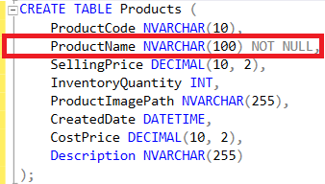

Figure 2-54: Sets "ProductName" as NVARCHAR(100) and NOT NULL

* CostPrice and SellingPrice:
* Must be numeric values: Ensure that these fields accept only numbers.
* Greater than 0: Prevent prices from being zero or negative, which are invalid for pricing.

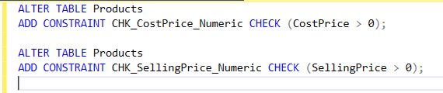

Figure 2-55: Adds constraints to ensure "CostPrice" and "SellingPrice" are greater than 0

* InventoryQuantity:
* Must be an integer: Ensure that inventory quantities are whole numbers.
* Greater than or equal to 0: Prevent negative inventory counts.

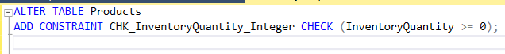

Figure 2-56: Ensures InventoryQuantity is non-negative

* ProductImagePath:
* Valid file path or URL: Ensure that the image path provided is correctly formatted.
* Maximum length of 255 characters: Prevent exceedingly long file paths or URLs.



Figure 2-57: Ensures ProductImagePath length is 255 characters or less

* Description:
* Maximum length of 255 characters: Ensure that the description is concise and within the character limit.



Figure 2-58: Ensures Description length is 255 characters or less

* CreatedDate:
* Must be a valid date and time: Ensure that the date provided is correctly formatted and valid.

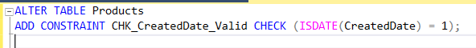

Figure 2-59: Ensure date provided is correctly formatted and valid

b) Employee Management

* Validation Rules:
* EmployeeCode:
* Must be unique: Ensure that each employee code is distinct and not duplicated within the database.
* Length between 1 and 20 characters: Enforce that the employee code is neither too short nor too long, fitting within the specified range.



Figure 2-60: Ensure each employee code is distinct

* EmployeeName:
* Cannot be null or empty: Ensure that every employee has a name provided.
* Maximum length of 100 characters: Prevent exceedingly long employee names.

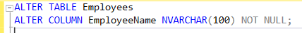

Figure 2-61: Ensure employee has a name provided

* Position and Authority:
* Cannot be null or empty: Ensure that both fields are provided.
* Maximum length of 50 characters each: Prevent exceedingly long values.

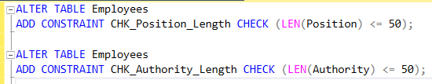

Figure 2-62: Ensure Position and Authority fields are provided

* Username:
* Must be unique: Ensure that each username is distinct.
* Cannot be null or empty: Ensure that every employee has a username.
* Maximum length of 50 characters: Prevent exceedingly long usernames.

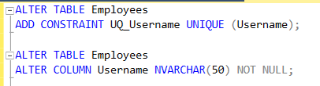

Figure 2-63: Ensure username is distinct

* PasswordHash:
* Cannot be null or empty: Ensure that a password hash is provided.
* Securely hashed: Use a secure hashing algorithm like BCrypt.

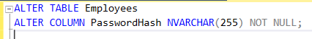

Figure 2-64: Ensure that a password hash is provided

* PhoneNumber:
* Valid phone number format: Ensure that the phone number follows a standard format.
* Maximum length of 15 characters: Prevent exceedingly long phone numbers.



Figure 2-65: Ensure that the phone number follows a standard format.

* AccessRights:
* Cannot be null or empty: Ensure that access rights are assigned.
* Predefined values: Limit to predefined values like Admin, Sales, Warehouse.

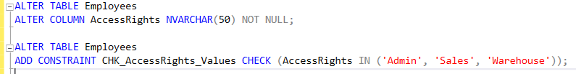Figure 2-66: Ensure that access rights are assigned

* CreatedDate:
* Must be a valid date and time: Ensure that the date provided is correctly formatted and valid.



Figure 2-67: Ensure date provided is formatted and valid.

c) Customer Management

* Validation Rules:
* CustomerCode:
* Must be unique: Ensure that each customer code is distinct and not duplicated within the database.
* Length between 1 and 20 characters: Enforce that the customer code is neither too short nor too long, fitting within the specified range.

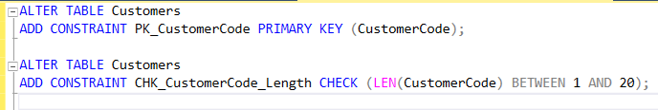

Figure 2-68: Ensure each customer code is distinct and not duplicated

* CustomerName:
* Cannot be null or empty: Ensure that every customer has a name provided.
* Maximum length of 100 characters: Prevent exceedingly long customer names.



Figure 2-69: Ensure that every customer has a name provided

* PhoneNumber:
* Valid phone number format: Ensure that the phone number follows a standard format.
* Maximum length of 15 characters: Prevent exceedingly long phone numbers.



Figure 2-70: Ensure that the phone number follows a standard format

* Address:
* Maximum length of 255 characters: Ensure that the address is concise and within the character limit.

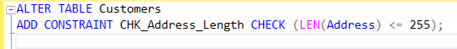

Figure 2-71: Ensure address is concise

* CreatedDate:
* Must be a valid date and time: Ensure that the date provided is correctly formatted and valid.

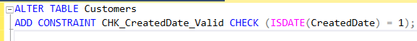

Figure 2-72: Ensure date provided is formatted and valid.

d) Orders table:

* Validation Rules:
* OrderID:
* Must be unique: Each OrderID should be distinct and not duplicated within the table.
* Auto-incremented: Automatically incremented by the database.
* CustomerCode:
* Must exist: Referenced CustomerCode must exist in the Customers table.
* Cannot be NULL: CustomerCode should always have a value.
* EmployeeCode:
* Must exist: Referenced EmployeeCode must exist in the Employees table.
* Cannot be NULL: EmployeeCode should always have a value.